
Little Rocky Run’s Issue 3 June 30, 2007

Stingrays Newsletter


Little Rocky Run Stingrays: Swimming for fun, winners for life

Stingrays Start Off the Season With A Win
LRR-268, Oakton-134
The Stingrays made an impressive start to the 2007 season with a great showing against the Oakton Otters. The Otters won the first race, but the Stingrays took most of the rest, taking 29 of 38 firsts in the individual events and 9 of 12 firsts in the relays.
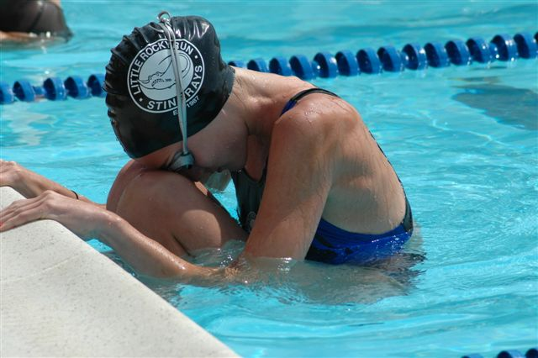
Leading the way were the 8&U girls, 11&12 boys, and 15-18, taking every first place and outscoring the Otters 26-6, 34-7, and 34-7, respectively. The 8 & U girl competitors were Carly Grecco, Chloe Ross, Katherine Bennett, Kameron Daily, and Elizabeth Murphy; the 11-12 boys consisted of Sean Hathaway, Jonathon Clarke, Daven Kim, Kevin Hagan, Luke Guthrie, Logan Aunon, and Nathan Marks; and the 15-18 girls were represented by Mo Hummel, Stephanie Kelly, Sarah Worley, Susie Lesniewski, Sarah Hadsell, Elyse Dietz, and Christy Nicholas.
Stingray first place winners were: Steven Kirk, Michael O'Donnell, James Murphy (2), Kyle Marshall, Sean Hathaway (2), Jonathan Clark (2), James Kintzing (2), Bobby Kelly, Brett Merker, Matthew Dietz, Elizabeth Murphy (2), Kameron Daily, Logan Ross (2), Sarah Hessler, Katie Yost, Shannon O'Donnell, Katie Schwindt, Taylor Avery (2), Susie Lesniewski (2), Christy Nicholas, and Mo Hummel.
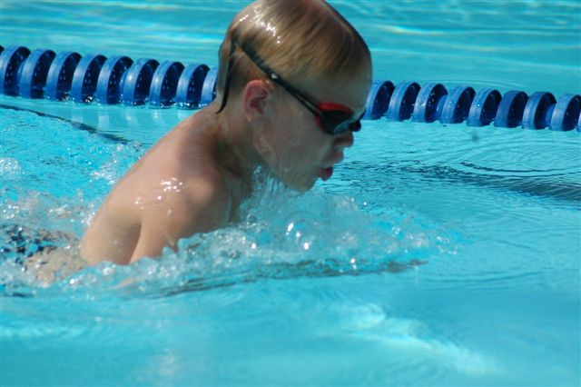
Stingray second place winners were: Kyle Cassidy, Jacob Kintzing, Carson McEver, Kyle Marshall, Luke Guthrie, Kevin Hagan, Bobby Kelly, Matthew Dietz, Kameron Daily, Carly Grecco, Kelsey Daily (2), Sarah Hessler, Katie Schwindt, Rachel Avery, Rachel Anderson, Caylin Zirzow, Jessica Sussman, Mo Hummel, and Sarah Hadsell.
Stingray third place winners were: Brandon Luke, Cole McCranie, Jack Danisewicz, Kevin Hagan, Luke Guthrie, Nathan Marks, Michael Helme, Monica Kirk (2), Abby McCranie (2), Rachel Anderson, Janelle Sykes (2), Erin Hessler, Christy Nicholas, Stephanie Kelly, and Elyse Dietz.

Two Team Records Broken On Against Otters
Starting off where she left off last year, Taylor Avery broke the 13-14 butterfly record that she set last year. Her time of 32.16 bested her 2006 mark of 32.25. The 9&10 boys relay of Kyle Marshall, Carson McEver, Jack Danisewicz, and James Murphy set the new team record with a time of 1:13.44, breaking the previous record of 1:14.32 held by J. P. Nicholas, Brett Merker, Brent Sikora, and Tyler Fisher.
Christopher Brown, Charlotte Hathaway, and Sarah Hessler are our first swimmers to reach gold this season. Many others are not far behind. Achieving silver this week are Jacob Kintzing, Collin McCranie, Michael O’Donnell, Katherine Bennett, Amanda Culclasure, Kameron Daily, Carly Grecco, Melanie Helme, Elizabeth Murphy, Paige Richbourg, Chloe Ross, Mitch Kiefer, Brady Madden, Cole McCranie, Carson McEver, Kyle Richbourg, Billy Yost, Ally Bedell, Kelsey Daily, Monica Kirk, Jackie O’Shea, Logan Ross, Jonathan Clark, Daven Kim, Nathan Marks, Esteban Molina, Pachel Anderson, Abby McCranie, Brooke Worley, Rafael Fuentes, Michael Helme, James Kintzing,Ben Mason, Andrew O’Shea, and Katrina Fuentes. Bronze finishers are Madison Purvis, Freddy Meny, Brent Rushing, and Rachel Avery. Congratulations to all of you!
Important dates to remember:
Friday, June 29 Pep Rally at 6:30
Sat. June 30 NVSL Meet #2 vs. Virginia Run
@ pool #2
Meet starts 9:00am
Mon., July 2 Fast Meet #3 vs Villa
@ pool #2
Meet starts at 6 pm
Tues., July 3 Time Trials 5:30 pm
Warm up starts at 5 pm
Family Night to follow
Wed., July 4 NO PRACTICE
Friday, July 5 Donut Day
Sat. June 30 NVSL Meet #3 @ Hunter Mill
Meet starts 9:00am
Meet at Centreville HS at 7:30, caravan leaves at 7:45
LRR Stingrays FAST Meet at Sideburn

The first Stingray Caravan led the swimmers down Braddock Rd. with a line of Stingray flags and blue ribbons hanging from antennas of mini-vans and SUVs to their final destination, the first FAST away meet at Sideburn Pool. Monday night showcased the work and dedication of our coaching staff and swimmers.
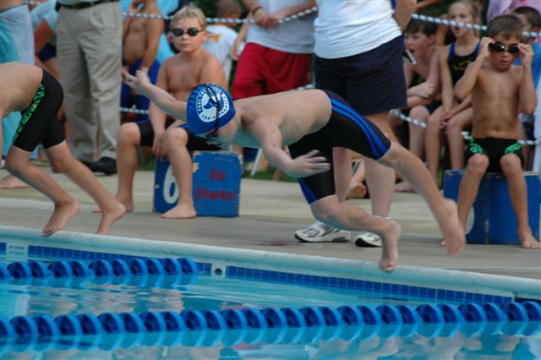
Overall, 109 Personal Best times were set, including an amazing improvement by Maya Fawzi, who improved her freestyle stroke by 65%. Other 25-meter improvements include Harrison Reinfried, who took 28% off his backstroke, and Joshua Kruse, who took 20% off his freestyle stroke. Emma Rechter and Jack Hess also improved 20%. Mitch Kiefer improved his 50m breaststroke by 15%.
First place finishers included: Myles Brown, Samuel Jackmore , Kelsey Marshall (2), Scott Ruelle, Laura Eom, Sydney Dolan, Christopher Brown, Monica Lawrence (2), Taylor Nappi, James Murphy, Elizabeth Murphy, Grace Warhurst, Alex Simmons, Logan Ross, Jonathan Clark , Rachel Avery , Rachel Anderson, Zach Sikora (2), James Kintzing, Colleen Marshall (2), Sam Maney, Andrew O’Shea, Katie O’Donnell (2).
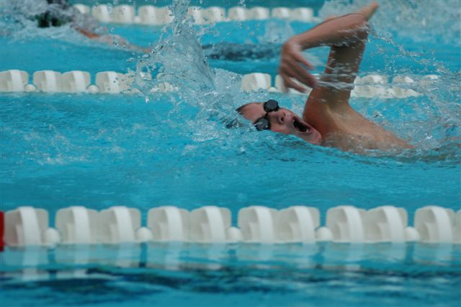
Second place finishers included: Myles Brown, Noah Helms, Delaney Madden , Madison Purvis, Madison Duncan, Ally Bedell, Natalie King, Madeleine Helms, Charlotte Hathaway, Laura Eom, Rosemary McGovern, Billy Yost, Andrew Taylor, Brent Rushing, Kyle Richbourg, Danny Meador, Abby McCranie, Matthew Rice, Matt Baron, Bobby Kelly, Meghan Givens, Rafael Fuentes, Katrina Fuentes(2), Daniel Molina, Sam Maney, Jessica Sussman, Taylor Knight, Colleen Knight, Rebekah Kintzing, Brian McLenigan, Susie Lesniewski.
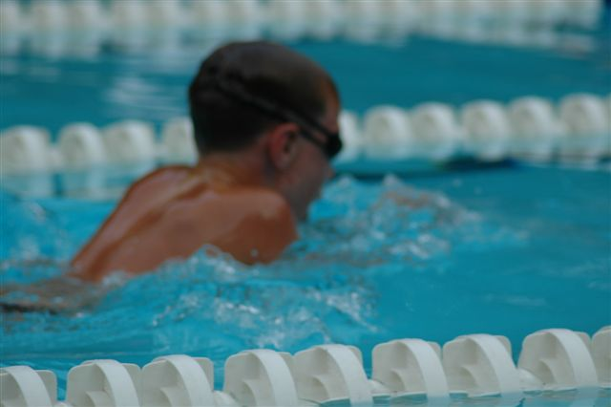
Third place finishers included: Samuel Jackmore, Melanie Helme(2) , Kyle Greenfelder, Sarah Kate Simmons, Brendan Cruz, Yevin Kim, Kelcie Greenfelder(2), Nada Fawzi, Taylor Nappi, Carson McEver, Michael Marrow (2), Jackie O’Shea, Connor Murphy (2), Esteban Medina, Ashley Leightley, Shannon O’Donnell, Matt Baron, Katrina Fuentes, Daniel Molina, Zachary Sussman, Stephanie Kelly, Mo Hummel, Alexandra McAuliffe, Sarah Worley.
Congratulations to these swimmers and all the other FAST meet swimmers who have been working hard to master their strokes!

Thank you coaches, volunteers and parents!

The “Gold Swimmer” program is used by the coaches to encourage swimmers to swim outside their comfort zone and participate in all events throughout the swim season.
Every swimmer will have the chance to go for the gold. There will be three levels each swimmer must reach. First, the swimmer must attempt to swim every stroke in a Monday meet, Saturday meet, or Tuesday time trial. Our 8&U will have to attempt to swim free, back, breast, and fly. All other age groups will also have to attempt the IM. Second, the swimmer must swim the strokes legally. Finally, starting with their times achieved at the first Saturday time trials, each swimmer will have to achieve five personal bests in any stroke or three in any single stroke. These steps may be achieved in any order and each step will advance them up the ladder to “Gold”. When they achieve the first step, they will receive a bronze ribbon. When they achieve the next step, they will receive a silver ribbon. And when they complete all the steps, they will receive the “Gold Swimmer” cap.
Let’s encourage each and every swimmer to try their best while reaching for “Gold”!
If you have any questions regarding the Gold Program, feel free to contact Karen McCranie at karen.mccranie@cox.net

Coach’s Trivia
Can you match the coach to their favorite stroke?

Christine Filak Freestyle

Mo Hummel Backstroke

Katie Lesniewski Breaststroke

Sarah Worley Butterfly

Check next week’s newsletter for more Coach’s Trivia.

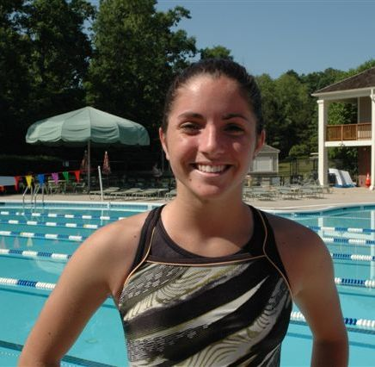
Junior Coach Tip of the Week:
Mo Hummel has been swimming for Little Rocky Run Stingrays since she was six. Her favorite tip to improve a young swimmer’s backstroke is “to get their kick’s up.” To do this she has a swimmer pretend there is a ball on the surface of the water and to try and kick the ball up into the air. This helps the swimmer concentrate on getting the tips of the toes pointed and helps them break the surface of the water. Thanks, Mo!

PEP RALLY
Team Spirit Motivates Swimmers
Little Rocky Run Stingray’s pride themselves on team unity. This Friday night at 6:30 and Saturday morning, the team will be rallying to defeat Virginia Run at home on Saturday and Villa at home on Monday night.
A pep rally is scheduled for Friday night at 6:30. Swimmers can bring a white T-shirt to tie dye while parents are asked to bring an appetizer and their own beverages. Pep Rally’s are an opportunity for swimmers to socialize and support each other outside of practice and outside of their assigned practice lanes. Coach Filak encourages older Stingrays to participate and meet the younger Stingrays. “It is more fun with the older kids support,” said Coach Filak. Friday night is also movie night at Pool #2 which will follow the Pep Rally.
Although, don’t stay up too late on Friday because whether you are swimming on Saturday or Monday, all swimmer’s are encouraged to show up at the meet Saturday morning.
In home team tradition, Pool #2 will be decorated with a theme before the meet. This week’s theme is “Power Rangers.” That’s right Stingrays, get ready to morph into a superhero and use some of those turbo powers to defeat Virginia Run and Villa. Stingrays can dress up in Power Ranger theme, creativity is a must, and cheer on Stingray victory over Virginia Run. Also, in Stingray tradition, show up early (8:45) and catch the Stingray Coaches and older swimmers in a skit to rally team spirit.

Announcements:
The new Stingrays’ email address is up and running. If you did not receive the first announcement from the lrr_stingrays@cox.net address concerning the caravan to the Sideburn FAST meet, please send an email to lrr_stingrays@cox.net with the word "test" in the subject line. If your email account filters out unknown addresses, please add this email to your address book.

Attention all newsletter contributors and swim team event coordinators. The Stingray Newsletter deadline for submissions is Tuesday evening each week. If you have a submission that is running late or would like to be reminded of the weekly deadline, please send an email to minna.levin@eds.com. Also, all action photos are welcome, especially close-ups during a meet and those with several swimmers. We will try to publish photos based on a first come basis. Label all photos in an email with a cutline describing what event the photo was taken and all the swimmer's names. We may not publish every photo sent but are in the process of trying to upload team photos to a website. Send photos to minna.levin@eds.com or kanoconnor@aol.com.
Stingray Rebekah Kintzing is not only a great swimmer but a great photographer. She has agreed to join the Stingray Newsletter staff as a Team Photographer. So, when you see Rebekah out of the water, with camera in hand, make sure you smile for her!
Parent Question of the Week
Why do we have time trials in between meets?
Answered by Coach Filak:
When Coach Christine Filak was younger, often swimmers would get locked into the two strokes they swam each week. (Note: Swimmers are only allowed to swim two strokes a week, this includes the FAST and NVSL meet).The time trials offer swimmers a chance to get a time in the stroke they have not yet mastered. This is especially helpful for swimmers that are learning and practicing a new stroke but it is not their dominant stroke.
Please send parent’s questions to kanoconnor@aol.com. Names will be kept anonymous and will be addressed to the appropriate coach or volunteer. Questions for the board and team representatives are also encouraged.
Swimmer's Corner
From the Stingray Archives
Three years ago, our Assistant Coach Andrea Martin answered these questions when she was a senior.
Ask a Senior
(Originally published July 16, 2004)
Question from Kevin Hagan (8 yrs old)
When I swim in a meet, am I supposed to wait for all swimmers to finish the race before getting out of the water? Why?
Answer from Andrea Martin
I wait for all the swimmers in my heat to finish the race before getting out of the water. This shows respect for your teammates and demonstrates good sportsmanship.
Question from Lauren Knoble (10 yrs old)
What should I eat before a meet? How early should I eat before the meet?
Answer from Andrea Martin
Before a Monday night meet I would probably try to eat a balanced meal with carbs and protein. (Example: small bowl of pasta and some chicken) I would early enough before the meet so my body could digest my dinner but not need to eat again until after I finish all my races. For me this is probably about an hour.
To start our own "Ask a Senior, 2007", please send any of your swimmer's questions to kanoconnor@aol.com
Teammates of the Week
Teammates and friends, Alex Aguilera (left) and Mitch Kiefer (right). Both swim in the 9 & 10 age group.
Alex and Mitch's favorite stroke is breaststroke. Alex describes the pull-out as his favorite part, "wait three seconds, pull, wait three seconds then kick." Alex describes the stroke with full motion while standing on deck near the lifeguard shack. We also asked Alex and Mitch their favorite thing about swim team. Alex did not hesitate, "donut day," he says. Mitch voted for the Kings Dominion trip.
New Parents Perspective

Learning to swim, like riding a bike, is a childhood milestone that most parents immortalize through pictures and videos of our children’s smiles after they take that first stroke or first ride around the school parking lot without training wheels. I never had high aspirations that I was raising a world class athlete, as I watched my child venture out of the shallow end on a hot pool day or careen down my court with his feet on the bars of his bike, that is, until now. Okay, maybe Lance Armstrong is a long shot but whose to say one of our swimmers isn’t the next Janet Evans or Michael Phelps.
Five weeks ago, before visions of swimming scholarships and the Olympics, I became a new swim team parent. There are always a handful of us each year. We are usually the first parent on the deck, when we know there are strict rules about not accompanying your swimmer into the practice area. We overwhelm the Coaches with initial questions. We hang out a little too close to the timers at the first meet. We are the parents that didn’t realize we should be equipped with a handful of ones for several snack bar runs each meet. And then we begin to find our groove.
My first “Aha” moment in the beginning of practices was to sit back and watch who the players were. “The players” are the parents who make the Little Rocky Run Stingrays a success and can usually answer most of the swim team questions without hesitation. Being a Stingray parent is second nature to them. They schedule their child’s individual lessons before the rest of us and plan their vacations and summer camps around the NVSL schedule. Befriending a “player” is definitely one way to tackle the overwhelming swim season schedule and to learn basic swimming rules and terms.
Another way is to band together with the other new parents. It is always encouraging to know someone is in the same boat as you, or in this case, the same swim practice lane. Together, you can send each other email reminders to remember what is next on the schedule – from team photos to away meet caravans. It won’t be long before you graduate from new parent to “player.” To learn swimming terms on your own, visit www.usaswimming.org, they have an excellent glossary that even the experts can learn from.
In the past five weeks, I have learned that behind every successful Stingray is a parent willing to commit to the intense schedule yet still takes the time for their swimmer to participate in the events that bond a team, such as pep rallies, donut days and movie nights. It is the Coach’s and the swimmer’s job to find their beat in the water, but our job as a parent to roll out of bed early on Saturday morning even though your child is not swimming, sit through an entire Monday night meet for the last two minutes because your child has decided to try butterfly and smile even though they won their heat but DQ’d in the last stroke of their lap.
I’ve also learned to dream a little about a future career as a swimming parent. Will my daughter have a unique stroke like Janet Evans? Will my son topple records set by swimmers from countries I can’t even find on a map? Or will they take it one step further to Water Polo and Triathlons? I’ll let my children set their own goals at the right time, but while I am waiting, does anyone know a cable package with a twenty-four hour swimming channel? Thanks for the motivation, Little Rocky Run Stingray parents.

Coach Filak’s Team Knows Your Swimmer

School has only been out two weeks, but at practice, the swimmers can tell you they feel they have been swimming at Pool #2 for months. As the season set into full swing, our newsletter staff had a chance to interview Coach Christine Filak on her philosophy before each practice.
8 & Under- Since the first time trials, there are still over 100 swimmers to organize in the 8 & Under group. Although this has proved a challenge to our coaching staff, you will notice how invested the coaches are in our Stingrays by calling each child by name and knowing their swimming abilities. The 8 & Under group is split into different lanes based on abilities. Each practice, one coach man’s up the shallow end and helps the swimmers that are about to break through to a new milestone on their strokes. Many parents and coaches are impressed with this year’s organization and personalization of the 8 & Under practices.
9 & 10 - At the 9 & 10 age group practice, coaches concentrate more on “legalizing” each swimmer’s stroke. Flip turns and wall touches are an important part of each swimmer reaching their personal best. Those that are able to master their stroke are pushed for speed work and endurance.
11 & Over – There are still some 11 & 12 year old swimmers that need to work on “legalizing” their stroke and the coaching staff is dedicated to helping each of them reach their goal. After the older swimmers master their stroke, they are encouraged to reach out of their comfort zone with speed and endurance work-outs. During the older swimmer’s practice, Coach Filak has four coaches on deck to work the swimmers to achieve their best.
Thank you coaching staff, your dedication and time in and out of practice has helped our swimmers reach their goals.
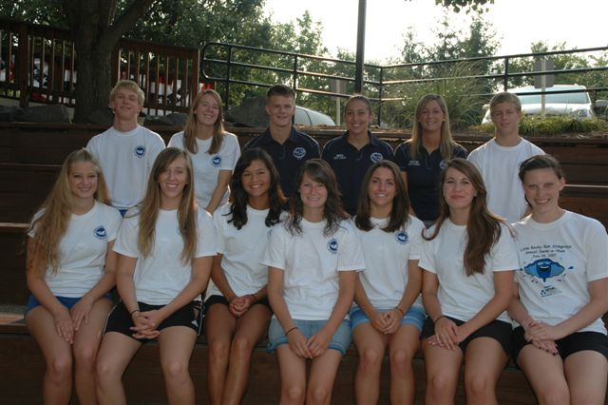

Pictures are posted at http://nvsl.nvblu.com/plasma/core/site/nvsl/grp/nvsl_littlerockyrun/screen/gallery?

