
Little Rocky Run’s Issue 1 June 16, 2007

Stingrays Newsletter


Little Rocky Run Stingrays: Swimming for fun, winners for life

Stingrays Season Begins

Greeting from the Team Rep
Welcome Stingray swimmers and parents. As many of you know, we have a wonderful swimming program at Little Rocky Run, as well as a tradition of producing large teams with excellent swimmers and competing well during Saturday and Monday meets.
"A love of the sport, advanced aquatic skills, teamwork, and the principles of good sportsmanship." These words from the Foreword of the NVSL Handbook not only reflect the virtues of the NVSL, but also the goals of our program. As in past years, in 2007 we strive to live up to these virtues. The coaching staff and board members have been working hard in the off season to set the Stingrays up for success.
Speaking of the coaching staff, we are fortunate to have Christine Filak returning as the Little Rocky Run as Head Coach, Andrea Martin returning as Assistant Coach, and the addition of Brolin Walters as Assistant Coach.
We are also fortunate to have Christel Hathaway as Assistant Team Rep. Christel will be leading the team at the Monday FAST meets and assisting in overall operations of the team. Please feel free to give Christel or myself a call, drop us a note, or grab one of us at the pool if you need to talk.
As stated above, the success we strive for is not only measured in points and seconds, but in developing the love of swimming, improving skills, teamwork, and sportsmanship. That being said, lets go out there and do our best to bring home the NVSL Division Two Championship.

NVSL Update

After competing in Division One last year and finishing with a 1-4 record, the NVSL seeding committee has moved the Stingrays into Division Two. In Division Two we will face familiar teams, going against Oakton, Virginia Run, Hunter Mill, Vienna Woods, and Fairfax Station. The last time we were in Division Two, 2005, we went undefeated and took home the championship. We are seeded FIRST, so the other teams will be looking to score upsets against us.
Initial Time Trials

The purpose of the Initial Time Trials is to establish a time for each and every swimmer in each and every stroke he or she is able to complete legally. EVERY swimmer should participate in the Initial Time Trials. If a swimmer has a conflict on Saturday, they should participate in the Makeup Initial Time Trials on Monday, 19 June. Don't count on getting a time on Monday, however, because if it gets rained out the swimmer will have missed out. If you can be there on Saturday, plan on swimming all strokes that you or your coach desires you to get a time in.
Swimmers have the opportunity to swim all four strokes at the Time Trial. These times are an important first opportunity for swimmers to get times that will be used for placing swimmers in events for the NVSL meets and for earning future Personal Best ribbons - - these times are not only important for the individual, but are important for the team because we want to put the fastest swimmers in the water for our first NVSL meet. A Personal Best is awarded every time a swimmer improves on their best time of the season. In order to improve, a swimmer must have that first time to improve upon. The legal times set at Time Trials are a swimmer's original times for 2007 - if their first swim is after Initial Time Trials, then that becomes their original 2007 time.
Time Trials warm-ups start at 7:30 am. Events will start at 8:00 am. Volunteers should arrive at 7:30am if no other time is specified. The Stingrays Store and Stingrays Café will be open all morning.
Good luck Stingrays...swim fast, have fun! See you Saturday.

FAST League Update

NEWS FLASH – Our first FAST League meet will this Tuesday, the 19th of June. The FAST League teams decided this year to have the first FAST meet prior to the first NVSL meet to allow the FAST Relay Carnival and the FAST IM Carnival to be held on Separate nights. Stay tuned for more information.

Christine’s Greeting

Hello Stingrays! I am very excited to be back here again this summer and to see so many familiar faces as well as so many new ones! We have such a large team this year and I am so happy that there is such an interest to participate on this team. The coaching staff has many fun and exciting things planned for this summer and hope that you are all as enthusiastic as we are about the upcoming season. Keep working hard at practice and good luck tomorrow!
-Christine

Talking about the Stingrays

Many of our Little Rocky Run families are very busy, so we try to make it easy for you to find out what is going on with the Stingrays. Of course, you are holding one of our main ways to communicate, the Newsletter!
Newsletter will be published every week and ready for pick up at pool #2 on Fridays. If you would like to contribute the article please email Minna Levin at minna.levin@eds.com no later then Tuesday evening.
The main Stingray bulletin board at Pool #2 is just inside the entrance to the pool. This board has announcements, the latest copy of the newsletter, meet results, personal bests, team records, and a listing of the top ten times on the team in each age group for each event. A second bulletin board is located between the locker rooms and has the volunteer assignments. You will also find event assignments for the upcoming NVSL and FAST meets posted.
The NVSL website, http://nvsl.nvblu.com - please note the new URL. Select “Little Rocky Run” from the TEAMS pull down menu to get access to our team website. The website has up-to-date NVSL meet results and swimmer times from NVSL meets. It also has a team calendar and list of upcoming events, team records, general articles and notices, a gallery of pictures, and a document center you can use to download handouts, handbooks, and registration materials.
The team hotline is 703-995-4888. This number will connect you to a recording where we try to provide up-to-date status on practices, meets, and special events. If the weather seems too bad to swim, check on the hotline to see if practice is cancelled. Since the pool is only closed by lightning or extremely heavy rain, which often comes and goes, the hotline will not catch every practice cancellation or suspension, however. The hotline may also have the latest info on swim meets or special events.
If you can’t find the answer to your question anywhere else, you can also e-mail the team rep, Chris Knoble, knoblefamily@verizon.net. He (or Katherine) will gladly reply, usually within 24 hours.

SWIM-A-THON

Swimmers, grab your fins and kickboards! The LRR swim team will be hosting a swim-a-thon on Thursday, June 28th from 9:00 - 11:30 am (immediately following the swim team photos.) Half of the proceeds will go to The Arthritis Foundation (Washington, DC), and the other half will benefit our team.
The swim-a-thon is not all work and no play. While swimming, there will be great music to listen to and all participants receive a free snow-cone. There will be plenty of door prizes to win and raffle drawings. Raffle tickets go on sale at the team pictures so bring your $1 bills and try to win an i-Pod shuffle, LifeTime Fitness gift packages, or a Webkinz, among other things.
Registration has already begun. The swim team table at pool #2 has the information packet that includes registration and pledge forms. Registration is $10.00 (checks payable to "LRR Swim Team") and runs through June 27^{th.} The first 100 swimmers to register receive a swim-a-thon t-shirt.
So, register now and start collecting those pledges (minimum of $10 in pledges required)! See you on the 28th, ready to have fun and swim for a worthy cause!

Show Your Stingray Pride!

Swim season has arrived and so has the new recognition program! It’s now time for each and every swimmer to show the coaches what they’ve got. There are many things the coaches look for in all of you. Of course they’re looking for good strokes, starts, and turns. And they would like you to get your fastest times! But they are also looking for a great attitude, determination, sportsmanship, and team spirit. Each and every one of you has something to contribute to this swim season.
This year, your coaches are watching you to see if you’re coming to practice, trying your best, and supporting your team. They’ve planned some special awards for those who show “Stingray Spirit” and great sportsmanship, in addition to the Swimmer of the Week. Don’t forget about all those personal best ribbons. These will be playing a part in the new “Gold Swimmer” program which starts at time trials and ends with the last meet of the season. Look for more details in next week’s newsletter.

Help Wanted
Volunteers make this swim team work. We all appreciate the hard work that each of us contributes to make the Stingrays happen. If it’s not obvious, nothing happens in NVSL without volunteers. We have a number of critical volunteer positions that need to be filled—some sooner and some later. Please consider if any of these are right for you!
Important dates to remember:
Sat. June 16, 8:00am until 12:00pm
Time Trials at Pool #2, warm ups 7:30am
Mon., June 18 NO PRACTICE Last Day of School
Mon., June 18, 6:00p -9:00pm
Make-up Time Trials at Pool #2, warm ups 5:30p
Tues., June 19 Morning Practice Starts
Tues., June 19 FAST MEET #1 v. Sully 2 @ home
6:00 pm @ pool #2
Warm ups begin at 5:10pm
Fri., June 22, Practices at Pool #3!
Coaching Staff
Little Rocky Run is fortunate to have a large coaching staff, which allows each lane of our younger age groups to have dedicated coaching. The coaching staff divides each practice into the available lanes according to experience and ability. With the coaching mix available to us, we can give every swimmer attention from a coach in the way most helpful to the swimmers progression. A “Coaches Box” is located at Pool #2, this box is the best way to initiate communication with the Coaches. The Stingray coach’s first priority during practices is to focus on the swimmers, as a practice ends the next practice quickly begins which doesn’t provide much time for communication. The coaches will contact parents, typically within 24-48 hours of receiving a note in the Coaches box.
Head Coach: The head coach focuses her attention on the most experienced swimmers in one or two lanes who are concentrating on strength, speed, and race strategy. The head coach carefully reviews all swimmers times from the weekly time trials, NVSL meets, and FAST meets along with receiving weekly evaluations from his assistant coaches, swimmers will be moved from lane to lane to best meet their needs. This individualize approach is only possible due to our experienced coaching staff. The Stingrays are one of the few teams in this area to have a program, which allows each swimmer to be continuously evaluated, by a skilled coach. The head coach directly coaches all swimmers in the 13 and over group, both NVSL swimmers and FAST meet swimmers. The head coach is responsible for the overall running of the swim team.
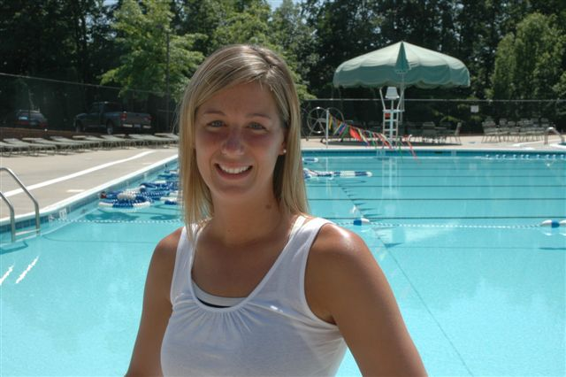
Christine Filak: This is Coach Filak’s second year as Head Coach of the Stingrays. Coach Filak grew up as a Stingray and developed into a skilled and competitive swimmer. She just finished swimming at JMU, as a graduate student. Coach Filak was a Head Coach in the summer of 2005 for another club and had been a Stingray Assistant coach in prior years. Coach Filak brings a wealth of knowledge regarding the latest and greatest swimming drills and coaching techniques. We are thrilled to have her back where she belongs, as a Stingray once again!

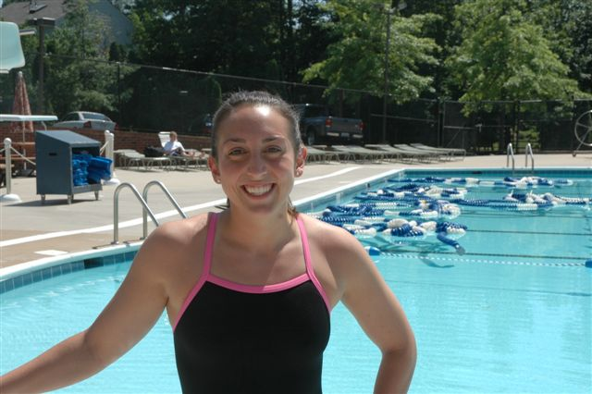
Assistant Coaches: The assistant coaches work with swimmers with varying experience and ability, including those less experienced swimmers who need to concentrate more on technique and stroke-work. The assistant coaches typically oversee various lanes during practice and provide instruction to all swimmers.
Andrea Martin Coach Andrea swam with Little Rocky Run since starting as an 8&U. She currently swims at George Washington University and was a stingray assistant coach past two summers. Andrea is known for her ability to effectively teach proper stroke technique. She is a highly skilled coach and we are so happy she is coaching again this summer.
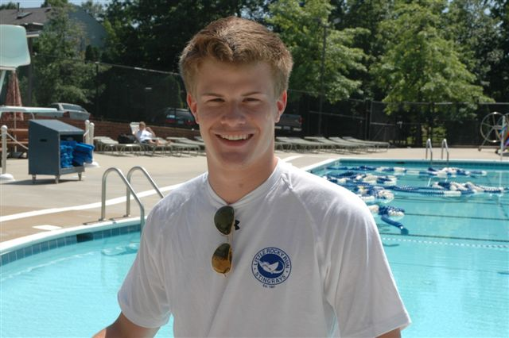
Brolin Walters enters his first season as a Stingray coach. He is currently a coach with the Mason Makos and previously served as an assistant coach for the Hayden Village swim team.
Brolin, who will be entering his sophomore year at George Mason University in Fall, graduated from Fairfax High School where he was a member of the swim and dive, football, and lacrosse teams. He served as Co-Captain of the Fairfax swim and dive team and qualified for the State Championship during his senior year.

Junior Coaches: Junior coaches assist with the 8&U practices and, early in the year, help with the mid-age groups. Our junior coaches are also swimmers for the Stingrays and their high school teams. This year’s staff includes: David Barchet, Elyse Dietz, Moe Filak, Laura Freeman, Mo Hummel, Stephanie Kelly, Taylor Knight, Katie Lesniewski, Bret Merker, Kathryn Peterson, and Sarah Worley.
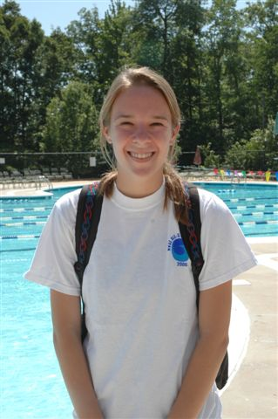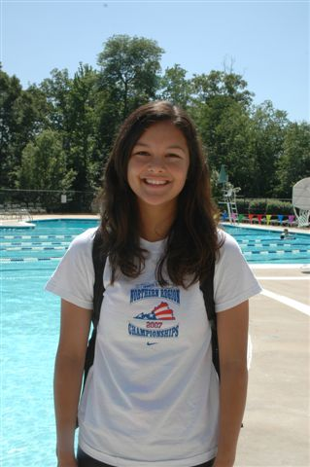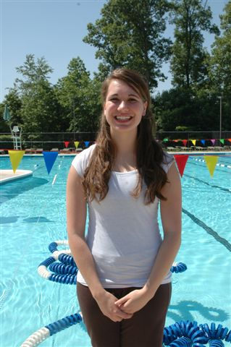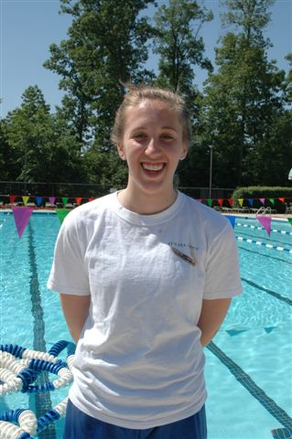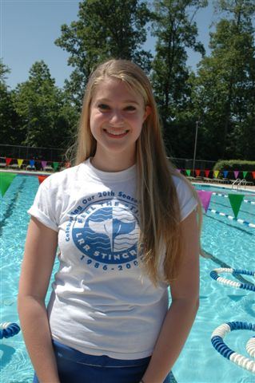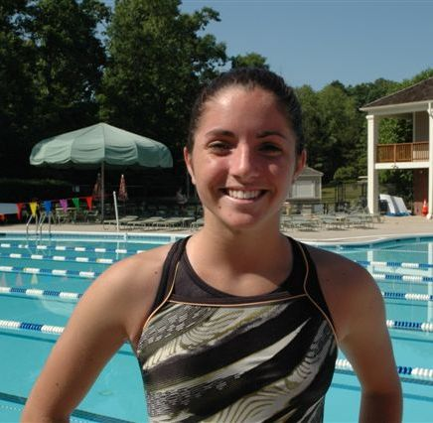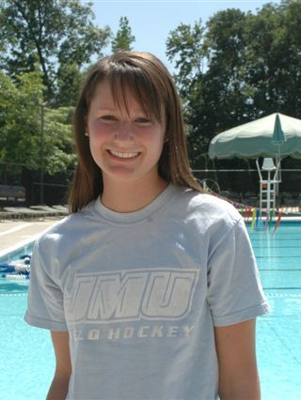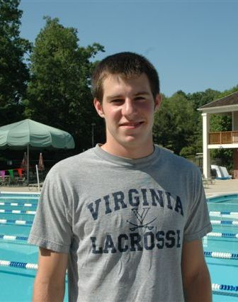

The 2007 Stingray Suit

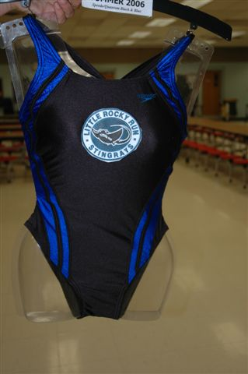
This year we are using the 2006 Stingray Suit. It proudly displays our team logo on both the girls and boys suits. Although team suits are not required to join the swim team, it is strongly encouraged as it brings us together as a team and it's a great way to show your team spirit. Some swimmers wear racing suits during the meets, which is fine but team suits should be worn for our team pictures. If you need to order a suit, please go to Cassels Sporting Store as soon as possible. Since the suits have logos the production time is longer so please don't wait. Go Stingrays!
We have lots of new apparel items for sale this season. Please contact Jennifer Marks if you would like to order specific items or come prepared to shop at our home meets.
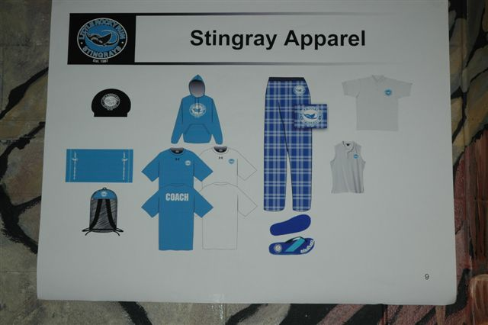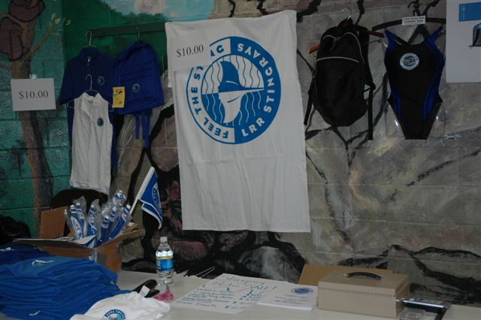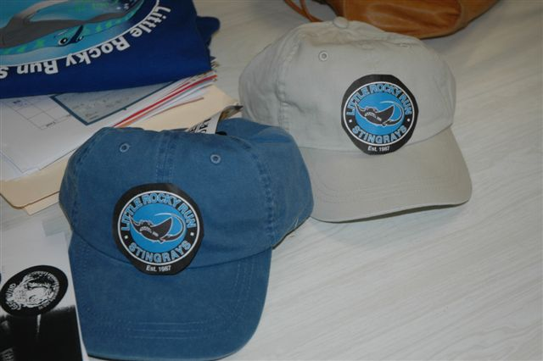

Who's Who

Team Rep: Chris Knoble. Chris is the top dog! He oversees the coaching staff and the overall swim team. Chris is responsible for the NVSL Saturday meets. Families are encouraged to contact Chris with concerns, questions, comments or compliments about the swim team by email at knoblefamily@verizon.net. In addition, notes may be left for Chris at pool #2 in the Parent Box. Chris makes every attempt to respond within 24 hours. Chris attends all the Saturday swim meets and will be seen at most time trials and FAST meets. He welcomes families to approach him with questions or concerns.

Asst. Team Rep: Christel Hathaway. Christel oversees the Monday FAST meets and welcome families to contact them with any concerns throughout the season. Christel can be reached by email at christelstringray@msn.com or by phone at (703) 830-6179.

Stingray Store: Jennifer Marks. Looking for stingray shirts, shorts, swim cap, swim bag or even a stingray tattoo? Well, Jennifer has it all. She sells great Stingray apparel at the home swim meets. Want to place a specific order for stingray apparel? Jennifer handles all the preseason orders and also obtains the team t-shirt for each swimmer. Each swimmer gets a team t-shirt with their registration, these t-shirts will be given out at the Stingray Spirit Day.

Welcome Wagon: Joan Hessler. Are you a new family to the stingrays? If this your first year or even your second year, then you will most likely have lots of questions that need to be answered. Please contact Joan Hessler by email at jwhessler@cox.net or by phone at (703) 222-4389. Joan is one of the friendliest people you will ever meet and she has ALL the answers.
Volunteer Coordinators: Jennifer Marks, Barbra Noel, Lou McEver. It takes many volunteers to run the swim team and these ladies keep it all very well organized. A volunteer board is located in the hallway leading to the bathrooms at pool #2, this is where you will find a current listing of your volunteer duties. If you should be in doubt about your volunteer duties, please contact one of the volunteer coordinators. In mid June, families will be contacted by one of the volunteer coordinators regarding your assignments for the season. If an unavoidable conflict arises, please arrange a substitute and contact one of the coordinators. Also make a note of the substitution on the bulletin board since the board will be used to show the actual volunteer team that made that activity run smoothly. Jennifer Marks msumarks@cox.net (703) 222-3751, or Barbra Noel macyrules@verizon.net, (703) 266-0180, or Loe McEver crsn01@aol.com (703) 830-5301.
Registration/ Computer Support: Barb Hagan. Barb handles Stingray registrations and maintains a sometimes-temperamental database. As the swimmers compete in the NVSL meets, FAST meets, and time trials each week, they will earn times that are recorded in the database.
Concessions Coordinator: Katie Murphy. A very important part of the swim team is the fun and social aspect of making new friends, and hanging out with old buddies……and of course, that means eating too! Our "Stingray Cafe" provides delicious favorite foods like hotdogs, hamburgers, pizza, grilled chicken sandwiches, nachos, ice cream and tons more! Katie is in charge of keeping us all well fed throughout the swim season, and boy they do an outstanding job! A large part of our volunteer pool with work at the Stingray Cafe, and Katie will help you each step of the way. Katie can be reached at murphyclan5@verizon.net or by phone at 703- 830-5530.
Newsletter: Minna Levin. The Stingray newsletter will come out each week, focusing on the fun and exciting news of what’s going happening. It also provides an overview of the meets and provides important information to all swimmers and families. Please feel free to contact Minna with Stingray news. Contact Minna at minna.levin@eds.com 703-867-8696.
How do I get my child’s times?

This is a common question each year. The best way to keep track of your child’s times is by writing them down after they swim each event. Look at the board behind the timers and you will see your child’s time posted at the completion of his/her swim. Many experienced parents keep a small notebook handy that makes it convenient to keep track of the times. If you missed the posting of your child’s times, you may contact our data coordinator, Barb Hagan, via email at haganjb@cox.net (contacting her at during a meet while she is doing entries is strongly discouraged). Please provide her with your child’s name, age and stroke swam. She will email you the times. Remember we have a very large swim team and just one very busy data coordinator, so try your best to write your child’s times down as they complete their swim.
Additionally, the top times for each event in each age group are posted on the swim team board at pool #2 weekly. At the end of the season, a summary of times and improvement is provided to each swimmer for all events.

How do I get private swim lessons for my child?
Many of our swimmers take advantage of our talented coaching staff by getting private lessons. If you are interested in scheduling lessons for your child, please contact the coaches directly. This can be done via the coaches’ box at pool #2, or by approaching the coach after practice. Each coach does their own scheduling so it’s best to contact them directly.
STINGRAY HOTLINE
703-995-4888 Please keep this number handy and use it often. This is the phone number you should call for weather updates, cancellations and to find out the happenings of the week.
Stingray Sportsmanship

Good Sportsmanship is a critical part of developing and maintaining a strong swim team. The Stingray Coaching Staff expects all swimmers, from the 8 & unders to the 15-18 year olds, to conduct themselves in a manner that represents our Swim Team in a positive light, both at practice and during swim meets. Here are just a few examples of ways to show good sportsmanship, we ask that parents encourage the following.

At Practice:
- Be on time. Come to the pool deck and wait there until swimmers from the previous practice are finished and have cleared the pool. Swimmers should never play in the shallow area while waiting for their practice to begin, but rather wait on the pool deck.
- Lane manners: While swimming laps, if a swimmer taps on a fellow teammate’s foot or pulls lightly on their fin, the swimmer in front should stop and allow the other swimmer to pass. Ignoring a tap on the foot or the fin is considered poor sportsmanship. If any swimmer experiences fellow swimmers not allowing them to pass, they should notify the coaching staff about this behavior.
- Practice sessions: At the end of each practice, swimmers should quickly gather personal items and leave the pool deck so that the next group of swimmers can begin their session on time. Swimmers should never play on the pool deck, socialize, or sit in the pool area while another age group practice session is in progress.

During Meets (Both NVSL and FAST meets):
- Swimmers should remain with the swim team in the designated Stingray Team area during the meets. If a swimmer would like to get a snack or to quickly visit with their parents after their race, they should return to the team swim area as soon as possible.
- Swimmers are encouraged to watch fellow teammates swim and cheer them on; they will do it for you too!
- Swimmers should remain in the water until the last swimmer in your heat completes the race. For example, if you are the first one to complete your heat, wait until the very last swimmer hits the wall before getting out of the water. To leave the pool before the last swimmer completes the race is considered disrespectful. (This applies to weekly Time Trials as well).
- After your race, we encourage swimmers to congratulate the swimmer in the next lane by leaning over and shaking his or her hand.
- After completing your race, it’s fine to ask the timers for your official time. But, also remember to say “thank you” before walking off.
- After a meet, all swimmers should remain to help clean up the Swim Team area of any trash.


Help Keep Pool #2 Beautiful
We implore all Stingrays and their parents to keep the pool areas clean by throwing trash in the bins and double-checking that all gear is accounted for. We are finding litter problems in the bathrooms and on the decks after team activities. Furthermore, every day sees a greater collection of suits, towels, goggles, and clothing in the lost and found. The pool staff must discard older lost and found items if the amount becomes too great. Parents please double check with your swimmers that they have everything and check the lost and found for misplaced items.
Communication
Swim team is a fun and exciting part of the summer, but it is also a very busy time too because the stingrays have so many extra activities and events.
The last day of school is June 18 and there will be no practices that day.
Weekday practices starting June 21 are as follows:
Ages 13 - 18 8:00am— 9:00am
Ages 11 - 12 9:00am—10:00am
Ages 9 - 10 10:00am—11am
Ages 8 & under 11:00am—11:45am
To communicate with the coaches, please use the Coaches Box located in the office of Pool #2. PARENTS SHOULD NOT ASK THE COACH QUESTIONS DURING PRACTICES OR MEETS. Please remember to always fill out a form to let the coaches know if your swimmer is going to be absent for practices or meets. We want swimmers in all the lanes at meets and this easy-to-do piece of information will help the coaches keep our lanes full! Keep your hotline number handy for all swim team activities, meet information and weather delays.
Stingray swimmers—best of luck for a fantastic 2006 season. Swim with determination and represent your team with pride. Remember that good sportsmanship is just as important as winning. Personal development is also important so always try and improve your times. When you do your best, you are always a winner! Encourage each other and laugh with each other. Kind words build great teams! We want our Stingrays to do well but more important, we want them to have FUN!

Stingray Café

The most popular place at the pool? The Stingray Café! Kids swim hard and parents cheer and both need something cool to drinks and something good to eat. The Stingray Café is the place to visit. Stop by for your favorite treat. Volunteer to assist.

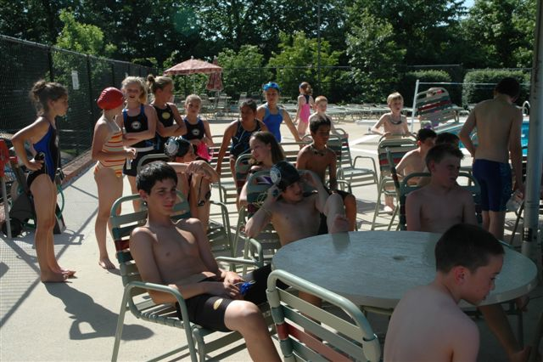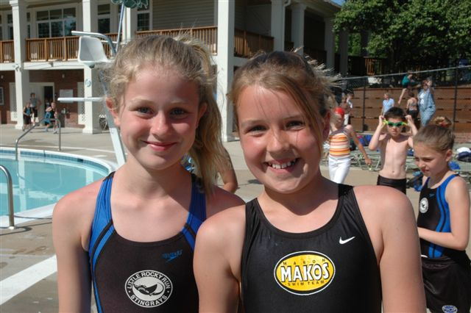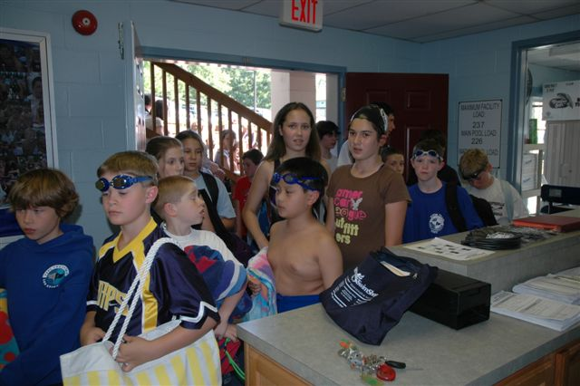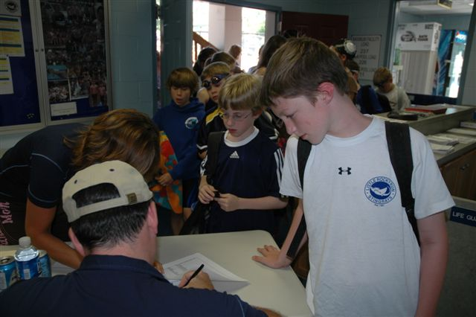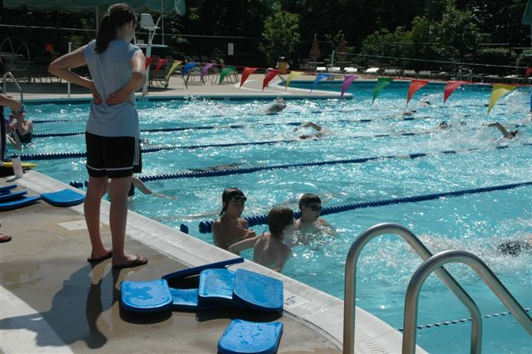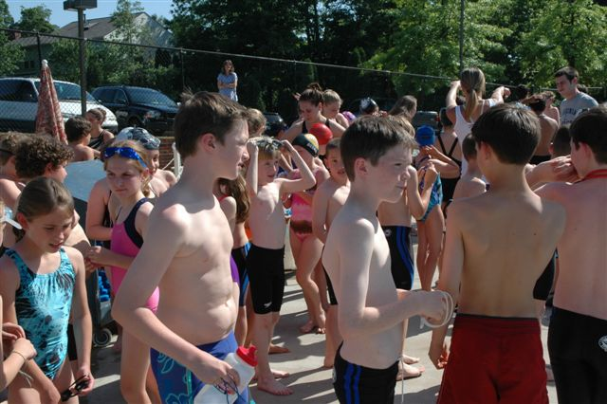

Going out of town? Have a Conflict? Let Us Know!

Make sure you fill out an Absence Notification Form

It’s the team policy to enter every swimmer in two stroke events every week between the NVSL meet and the FAST meet. The exception is that we do not want to enter a swimmer who isn’t going to be there. To let the team know when a swimmer is not available, each family should fill out an “absence notification” form. Do NOT assume that your swimmer won’t be asked to swim a meet. Even if he or she has always been entered in FAST meet events in the past, there is always a first time to be entered in an NVSL meet.

A no show to an NVSL meet is particularly difficult since we are limited to three swimmers per event in the first place, and it can affect the result of the dual meet. But, no shows at FAST meets are also a problem—they can prolong the meet and cost us in entry cards and materials.

Absence Notification forms are available at Pool #2. Enter each swimmer in your family who will be unavailable and check off each meet he or she will miss. Also enter the period of time that you will be out of town, since the coaches appreciate knowing about extended absences from practice. Place the completed form in the box. If you find out later about additional absences, submit another form—it is OK and even preferred to repeat absences submitted earlier on a later form.

