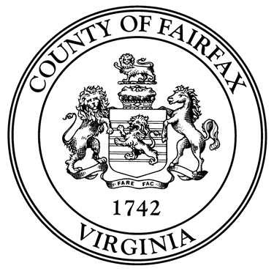
County of Fairfax, Virginia

To protect and enrich the quality of life for the people, neighborhoods and diverse communities of Fairfax County

REGISTRATION FORM
FOOD SAFETY WORKSHOP

There is a $25.00 fee, per organization, for attendance at a Food Safety Workshop. Please make arrangements with your organization for payment to be made. Registration will not be confirmed until payment is received.

The Health Department must receive this registration form at least 10 days prior to the date of the workshop you wish to attend. Note: Applicant must be at least 16 years old.

- Name: _________________________________________________________________

- Address: _______________________________________________________________

- _______________________________________________________________

- Home phone # ( ) _____-___________ Email Address: _____________________

Name of organization represented: ___________________________________________________

Please check below the workshop you wish to attend. Indicate a 1st and 2nd choice.
If your 1st choice is unavailable, we will contact you to confirm your 2nd choice.

NOTE: With a minimum of 15 attendees, special arrangements can be made to present the workshop to individual groups. Contact us at 703-246-2444 for further information.

Indicate  1st & 2nd choice | Workshop Date | Workshop Time | Course Location
 | February 15, 2012 | 5:30 -7:00p.m. | Fairfax County Health Department  Food Safety Section  10777 Main Street  Fairfax, Virginia 22030  Suite 111, 1st Floor  Maximum of 15 attendees per session
 | March 7, 2012 | 5:30 -7:00p.m.
 | March 21, 2012 | 6:00 -7:30p.m.
 | April 11, 2012 | 5:30 -7:00 p.m.
 | April 25, 2012 | 6:00 -7:30 p.m.
 | May 9, 2012 | 5:30 -7:00 p.m.
 | May 23, 2012 | 6:00 -7:30 p.m.
NVSL | June 2, 2012 | 10:00 – 11:30 a.m.
 | June 6, 2012 | 5:30 -7:00p.m.
 | June 13, 2012 | 6:00 -7:30 p.m.
 | June 27, 2012 | 6:00 - 7:30 p.m.

