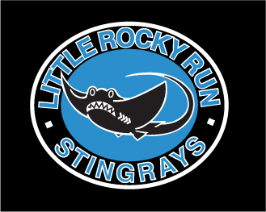
Little Rocky Run’s Issue 5 July 13, 2007

Stingrays Newsletter


Little Rocky Run Stingrays: Swimming for fun, winners for life

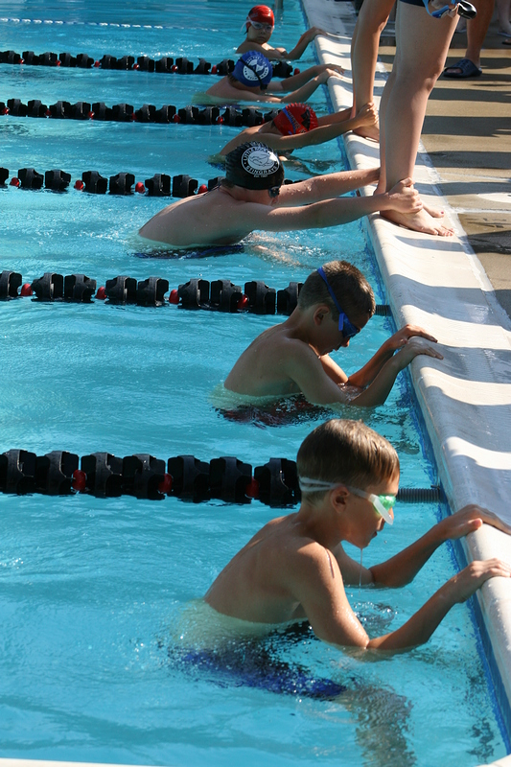

Stingrays Outswim Sharks
LRR – 222, HTM – 180

The Stingrays improved to 3-0, snaring the win against a tough Hunter Mill team. Continuing to rack up personal bests, Stingray swimmers improved their times in 44 of 114 swims, including another record-breaking performance by Taylor Avery. Besting the record she set last year in the 13-14 butterfly for the third straight week, Taylor lowered the mark to 31.94.
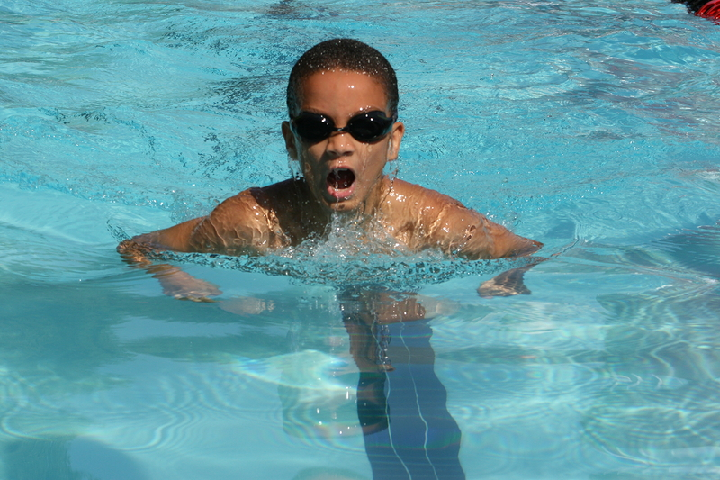
The Little Rocky Run victory was spear-headed by the 9-10 boys and 13-14 girls, who outscored their opponents 32-9 and 27-14, respectively. Congratulations to 9-10 boys James Murphy, Kyle Marshall, Carson McEver, Patrick Goldammer, Cole McCranie, Billy Yost, and Taylor Nappi, and 13-14 girls Taylor Avery, Janelle Sykes, Jessica Sussman, Caylin Zirzow, Erin Hessler, Katie O’Donnell, Colleen Marshall, and Julia Freeman.
Overall, the Stingrays and the Sharks split the individual first place finishes 19-19, so it was the second place (22-16) efforts, third place (26-12) efforts and the 7-5 relay advantage that made the difference in the meet.
Stingray first place winners were: Taylor Avery (2), Sean Hathaway, Sarah Hessler, Samuel Jackmore, Kameron Daily, Mo Hummel, Susie Lesniewski, Kyle Marshall, Abby McCranie, Carson McEver, Brett Merker, Elizabeth Murphy (2), James Murphy (2), Shannon O'Donnell, Logan Ross, and Janelle Sykes.
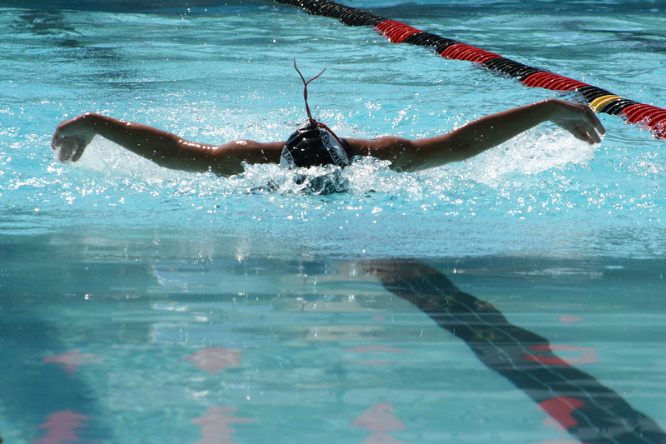
Stingray second place winners were: Rachel Anderson, Kyle Cassidy, Jonathon Clark, Kameron Daily, Matthew Dietz (2), Patrick Goldammer, Carly Grecco, Kevin Hagan, Sean Hathaway, Bobby Kelly, James Kintzing (2), Monica Kirk, Steven Kirk, Katie Lesniewski (2)Michael O'Donnell, Logan Ross, Katie Schwindt, Jessica Sussman and Katie Yost.
Stingray third place winners were: Rachel Anderson, Ally Bedell, Katherine Bennett (2), Kyle Cassidy, Sarah Clark, Luke Guthrie (2), Tyler Hagan, Erin Hessler, Sarah Hessler, Charlotte Hathaway, Susie Lesniewski Brandon Luke, Kyle Marshall, Abby McCranie, Cole McCranie (2), Christy Nicholas, Luke Paradis, Katie Schwindt, Janelle Sykes, David Welliver, Billy Yost and Caylin Zirzow (2).

Relay Carnivals 101

The following information has been extracted form the Stingray Handbook, which is found online at: http://nvsl.nvblu.com/plasma/core/grp/nvsl_littlerockyrun/screen/documents?folder_id=50469 .
Divisional Relay Carnival – Each NVSL Division conducts a Divisional Relay Carnival in which each team in the division has only one entry for each event. This meet is held on a Wednesday evening starting at 6:30 and takes 2 hours to complete. The relay teams in each age group are selected by the coaches in order to achieve the maximum number of points for the team. The Divisional Relay Carnival is important because the teams compete for team points and the Divisional relay trophy, and this is the qualifying meet for the All-Star Relay Carnival.
All-Star Relay Carnival – The NVSL conducts an All-Star Relay Carnival in which the eighteen fastest relay teams NVSL-wide compete. The fastest teams are selected based on the results of Divisional Relay Carnivals. The next fastest team is selected for each event to serve as an alternate. Being selected to compete in this meet is quite an honor. This meet is usually held on a Wednesday afternoon and takes 5 to 6 hours to complete. For 2005 and 2006, Little Rocky Run hosted the All-Star Relay Carnival.
Relay Carnival – The FAST League sponsors one Relay Carnival each season. This is a fun meet that is not scored. Swimmers who participated in the Divisional Relay Carnival do not compete in this meet. Medals and/or ribbons are awarded for each event. This meet lasts approximately three hours.
Schedule – This year, the meets are held July 11th at Virginia Run, July 18th at Springboard, and July 16th at Commonwealth.

FAST MEET at Commonwealth

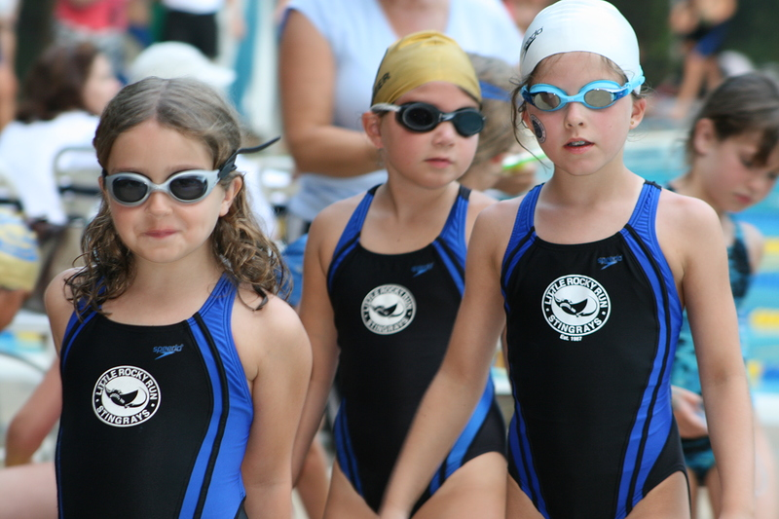
Our fourth FAST meet, at Commonwealth, produced our greatest amount of personal bests this season. Overall, 170 personal bests were achieved this week, up from 150 personal bests last week. Swimmers pushed their comfort zone and some of our younger swimmers swam breaststroke and butterfly for the first time.
Our most improved swimmers were Rosemary McGovern with a 36% improvement in breaststroke and Rachel Culclasure with a 27% improvement in backstroke. Rachel’s sister Amanda Culclasure also improved her breaststroke by 23%. Brother and sister teammates, Katharine and Thomas Rowzie, also improved over 20% in freestyle and back respectively. Other personal bests with over 15% improvements were swum by Jennifer Marty, Albert Pan, Joseph Purvis, Kyle Cassidy, James Holden, Lauren McGovern and Emma Odom.
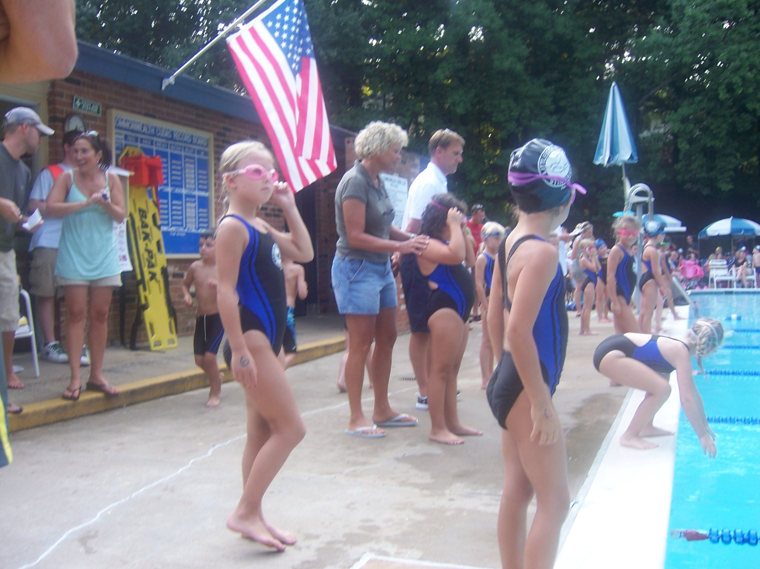
Thanks, for helping our young swimmers achieve their personal bests, go especially to Beth Bedell. She stood at the start of each event and checked goggles, slapped motivational high fives and gave endless encouragement.
Important dates to remember:
Friday, July 13 Pep Rally at 6:30
Sat., July 14 NVSL Meet #4 vs Vienna Woods
@ pool #2
Meet starts 9:00am
Sun., July 15 Lollipop Meet at pool #1
Meet starts at 12 noon
Mon., July 16 Fast Relay Carnival @ Commonwealth
Meet starts at 6 pm
Tues., July 17 Time Trials 6 pm
Warm up starts at 5:30 pm
Wed., July 18 All Star Relays
Thur., July 19 Splash Down
Fri., July 20 Donut Day
Sat., July 21 NVSL Meet #5 @ FF Station

Pep Rally Announcement
Come one, come all Spartan Gladiators to the Stingray's pep rally at 6:30 on Friday night. "Greek" is this week’s pep rally's theme. Wear your helmets and armor and bring cardboard to make shields. Bring poster board to make signs that show our "warrior" spirit and get pumped up for the Saturday meet against Vienna Woods. At 0845 on Saturday, our coaches will also do a skit using our Greek theme.
The Man Behind the Fun (and the horn)
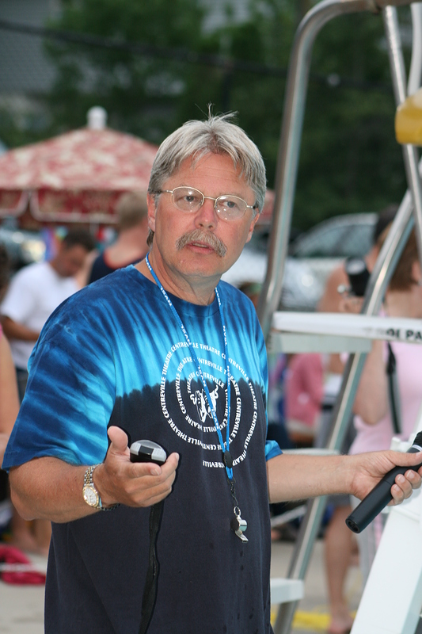
We’ve all seen him. He’s a fixture at every meet, time trial and Stingray event. He seems so official, reserved and above all, revered as a NVSL expert. Most of us have not shaken his hand and if you have, you take any knowledge he imparts and run with it to your appointed volunteer position. Mark Peterson is all that, and more. We could begin with the fact that he has single-handedly managed the Stingray Family Night since 1996 and has been an official at meets, and the Stingray’s starter longer than that, but it began much earlier —1962 to be exact.
“You cannot name another sport that involves both sexes and six year olds and eighteen year olds are teammates,” said Mark. Mark’s love of swimming and NVSL participation began in 1962 when he swam for Sleepy Hollow Recreation Team in Falls Church. He still currently holds the 11-12 record for breaststroke. As his in-laws still live near the Sleepy Hollow record board, he says that his wife occasionally asks someone to check if “M. Peterson is still up there?” He still is.
Mark swam in NVSL for nine years, coached for seven years and has been a NVSL parent and official for sixteen years. He dabbled in college swimming, but even after a few years off from the sport, he was immediately drawn back to the NVSL. “NVSL is the largest summer community swim league in the United States. It is regarded as the most sophisticated and best run community summer league.” Mark’s decision to move to Little Rocky Run was even driven by the NVSL. Once he found out that the Stingrays were a NVSL team, he was sold and chose Little Rocky Run to raise his family.
As Debbie Ross, Vera Brown, and Natalie Kiefaber can tell you, Mark’s Stingray claim to fame is Family Night. This year the family night was colder than an average July pool day and held on July 3rd, a popular beach day for most Stingray families, but the night was a success with Mark’s innovative games and help from Rachelle O’Shea.
The highlight of the night was the boat pull for the 9 & over group. The 8&U group loved diving for plastic dinosaurs and Easter eggs full of money. The girls won the fishing competition when it came to boys VS girls. That is okay with Mark since his current Stingray swimmer is Kathryn Peterson, also one of our junior coaches.
Mark first joined the Stingray parent team when his son Michael joined in 1993. Michael still holds a record in the Mixed Age Relay. We asked Mark, “What happens when Kathryn moves on from the Stingrays?”
“I’ll still be here, I guess.” Mark replied.
He also challenged the board for next year, “Give me a night that is not on a holiday and we’ll double the size of Family Night.”
Swim- A -Thon Results

Take a handful of enthusiastic and efficient volunteers, over 115 swimmers, a dedicated team of coaches, a list of over 25 donors and a cause close to our hearts and we end up with an overwhelming successful Stingray Swim-A-Thon. Heidi Peck and Susan Brown co-chaired the Swim-A Thon and had less than four weeks to plan the event that rose over $4500. One half of the contributions will be donated directly to the local chapter of the Arthritis Foundation to help children who suffer from Juvenile Rheumatoid Arthritis (JRA).
Katie Coritz was our highest fund-raiser for the Stingray Team and Arthritis Foundation. She raised $290 while Jacob Bowman raised $180 and Brendan Cruz collected $153 for his participation. Jack Hess and Grace Warhurst both brought over $100 to the charity event. Other swimmers that raised between $50 and $100 include Lexi Benton, Chloe Ross, Ryan Hess, Anna Denbigh, Samuel Maney, Carly Grecco, Jack Danisewicz, Sidney Kiefaber, Logan Ross, Brent Rushing, Lindsey Peck, Matthew Baron and Jonathan Clark.
Family contributors of $50 or more includes the Hess Family, the Ross Family, the Kiefaber Family, the McCranie Family, the Marks Family, the Brown Family, the Purvis Family, the O’Connor Family and the Peck Family.
Over 115 swimmers participated and swam 8,125 lengths which translates to 126 miles. Katrina Fuentes, Colleen Marshall, Abby McCranie and Katie Yost swam the maximum laps allowed, 200 lengths. Thirty-three swimmers swam between 100 and 199 lengths.
Heidi Peck and Susan Brown credit the help of their team of volunteers for such an outstanding success. They would like to thank Mary Helme and Nathalie Freeman for tallying all of the statistics and inputting the data. Susie Grecco livened up the day by MCing the event. Nancy Taylor designed the t-shirt. Joanie Grimm manned the raffle table. Susie Grecco, Susan Brown and Joanie Grimm teamed up with Nan Krishna and Colleen Baron to solicit for donations (see donor list). Nan and Colleen were also on hand the day of the Swim-A-Thon to help with logistics.
Heidi, a new swim team parent, and Susan, a first time coordinator for the Swim-A-Thon both agree the best part of the event for them was working with the fun group of volunteers. Heidi, who four weeks ago did not know what a Swim-A-Thon was, also said, “The coaches made the day phenomenal because they kept the kids participating.” Whether it was counting lengths, dancing to the music, or giving piggyback rides in the shallow end, the coaches showed endless energy and made the event even more fun for the swimmers.
Susan and Heidi also made sure that every child left the Swim-A-Thon with a prize. This wouldn’t have been possible without our list of donors. Case Home Improvement, owned by the Longhorne family, was our largest donator. The Langhorne Family’s business donated $200 to the event. Other donors included Union Mill PTA, 7-Eleven, Starbucks Coffee, Papa John's Pizza, Peterson's Ice Cream Depot, Best Buy, McDonald's, Pomodoro Pasta, Pizza, and More, Trader Joe's, IHOP, Giant Food, Rosemary's Thyme Bistro, Blockbuster Video, Tony's NY Pizza, Lifetime Fitness, Temptations Gifts, Maggie Moo's, Manhattan Bagel, Glory Days Grill, The Baron Family, The Clark Family, The Lione Family, The Madden Family, The McAuliffe Family and The O'Shea Family.
Thank you Heidi and Susan for such a fantastic day and a special note of thanks to Lauren Peck, our DJ, and her father Scott who provided and set up the sound system.

Personal Bests Aren’t Always in the Pool

The Stingray Charity has always been a prevalent part of each swim season and this year we are donating half of our charitable contributions to the Arthritis Foundation, a disease that has hit close to home. For many years, the team donated to the Juvenile Diabetes Association because we had a team member with Juvenile Diabetes. She soon had to choose between dance and swim. Dance won out and she retired her Stingray Jersey.
At the same time she moved on to dance, Christian Knoble was diagnosed with Juvenile Rheumatoid Arthritis (JRA.) The Knoble family went through a tough sixth grade year with Christian, where he had to be home-schooled most of the year.
During the tough times, Christian was unable to walk, grew very weak, lost weight, dealt with immense joint pain and had high nightly fevers. Finally, after three and a half years of medical treatment and a combination of the right medicine, Christian is able to play basketball on a team this summer. He also attends CVHS where he is earning straight A’s in all his classes, including honors courses.
In addition to Christian, another Little Rocky Run child, Elizabeth Frank was diagnosed with JRA and had to stop competing in gymnastics. She tried swimming last year and soon grew addicted to the sport. She is not on the team this year due to other commitments, but will most likely return next year.
JRA is not as widely known, nor is it like the arthritis that people suffer as they get older. Juvenile arthritis is an auto-immune disease that can be severe if left untreated. There are three types of JRA and Christian has systemic JRA. For more on this disease and other rheumatic diseases that affect children, please visit http://ww2.arthritis.org/conditions/DiseaseCenter/typesofJA.asp.
Thank you to the Knoble Family and Christian and Elizabeth for allowing us to share your story. We are proud of our swimmers that raised money that will go directly to the Washington Chapter. The local chapter has a huge population of children with JRA and the funds will go to directly help those children in our area. We will present the foundation with a check at the end of our year awards party.

Thirty-four More Stingrays Get Gold !


Many more Stingrays joined the Gold Club this week. They were Katherine Bennett, Myles Brown, Kyle Cassidy, Sarah Clark, Brendan Cruz, Kameron Daily, Nada Fawzi, Katrina Fuentes, Patrick Goldammer, Luke Guthrie, Jennifer Hagan, Kevin Hagan, Tyler Hagan, Melanie Helme, Michael Helme, Noah Helms, Sam Jackmore, Sidney Kiefaber, Bobby Kelly, Natalie King, Andrew Kurowski, Ashley Leightley, Abby McCranie, Carson McEver, Freddy Meny, Daniel Molina, James Murphy, Taylor Nappi, Andrew O’Shea, Madison Purvis, Matthew Rice, Paige Richbourg, Grace Warhurst and Katie Yost.
Achieving silver were Rachel Avery, Matt Baron, Julia Freeman, Grace Guthrie, Will Hadsell, Steven Kirk, Patrick Muradaz, Madison Noel, Albert Pan, Brent Rushing and Alex Simmons.
Reaching bronze were Taylor Avery, Michael Bishop, Sarah Bishop, Laura Eom, Maya Fawzi, Michael Frongello, Sean Hathaway, Allie Humes, Rylie Kiefaber, Katie Lesniewski, Daniel Levin, Soo Lim, Colleen Marshall, Kyle Marshall, Jennifer Marty, Alexandra McAuliffe, Lauren McAuliffe, Lauren McGovern, Andrew McLenigan, Austin Mysinger, Katie O’Donnell, Albert Pan, Lindsey Peck, Emma Prosser, Joey Purvis, Harrison Reinfried, Katharine Rowzie, Scott Ruelle, Genevieve Thanh, Cassidy Watkinson and David Welliver.
Way to go Stingrays!

Swimmer of the Week
Boys Girls
15-18 none Jen Hagan
13-14 Andrew O'Shea Katrina Fuentes
11-12 Devin Kim Ashley Lightly
9-10 Kyle Richbourg Grace Warhurst
7-8 Albert Pan Katherine Bennett
6 & U Ryan Ross Lexi Benton

Kings Dominion /Splash Down

Once again this season the Stingrays will be enjoying day trips to
Kings Dominion and SplashDown Waterpark. The original dates for these activities will be switched. The Stingrays will be enjoying SplashDown Waterpark on Thursday, July 19th. The week after that we will be heading down to Kings Dominion on Wednesday, July 25th. More information on both of these events will follow but be watching for how you can get tickets! Mark your calendars now!
You won't want to miss out on either of these events!

Ask Joan (Hessler)

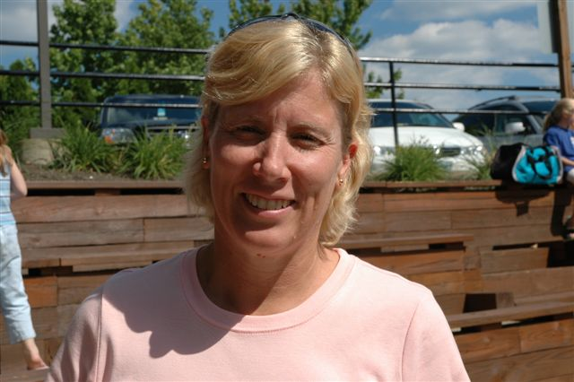
Are you still sitting in the brown bleachers practice after practice waiting to ask that one question? Don’t be shy, Joan is here to help. Email Joan, our new parent coordinator, at jwhessler@cox.net to receive an answer to your questions about swim team. No question is too big or too small or too late in the season. Here are some recent questions asked that may help some new (and some old) swim team parents:
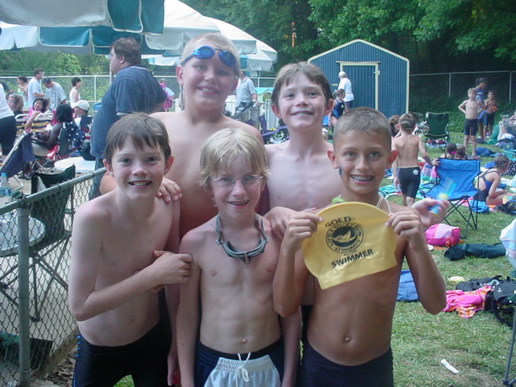
Question: What is the impact of a DQ on a time trial? Will it affect my children swimming in the meet? Is there an opportunity (and/or a need) to execute a good time
trial?
Joan: A DQ has no impact. They will swim in the meet and try again! If they DQ in a meet they would not receive a place ribbon if they place but will still receive a participant ribbon.
Question: So swim meet to swim meet we will not know if our child swims till the list is posted? Is that right?
Joan: Yes, that is correct.
Question: Do you know where I can get a parent handbook? The guidelines that we received during registration referred to a handbook, but I didn't receive it.
Joan: The handbook can be downloaded from our website which is http://nvsl.nvpools.com/core/core/domain/nvsl/group/littlerockyrun. Go to the "find" block and search handbooks.
Question: Are all the FAST meets at 6 pm and are all the NVSL meets at 8 am?
Joan: The meet times you have are correct, but warm-ups usually begin about 45 minutes earlier.

STINGRAY STORE NEWS

Attention Parents
The Stingray Store will be open for business on Saturday, July 14 and Tuesday, July 17. come shopping for the last time to buy gifts for the holidays, birthdays and other occasions throughout the year. Lots of sweatpants and sweatshirts are left for the perfect winter gift. There are also some polos, flip-flops and other swim necessities to carry your swimmer throughout the rest of the season.

Junior Coach Tip of the Week
Brett Merker has been swimming for the Little Rocky Run Stingrays since he was seven years old. His favorite Stingray memory is breaking the 13-14 record in breaststroke. He didn’t know that he had broken the record until his coach approached him later in the meet, “And I was amazed,” said Brett. He also currently owns the 11-12 Stingray record in breast stroke. Coach Merker’s favorite tip to share with the younger swimmers is to “keep your head back on backstroke.” Brett also offers advice to parents, “Pressuring your children into swimming won’t help them enjoy the sport. It is having fun that really helps.” A junior at Centreville High School, Brett swims for the Wildcats and hopes to swim in college where he’d like to pursue a degree in finance or business. Thanks, Brett!

Parent Question of the Week
Our question of the week was answered by Coach Filak, Assistant Coach Brolin Walters and junior coaches Elyse Dietz and Brett Merker.
What do you find yourself repeating over and over to swimmers at practice?
There seemed to be a common theme in their answers:
“Don’t breathe every stroke”
“Don’t take breaths inside the flags” and
“Don’t breathe into your walls” were all agreed to be the most repeated tips for all swimmers.
Casino Night in Paradise!
Join us for an adult evening at the pool. You must be at least 21 to attend. Ticket price includes "funny money", all you care to eat and drink, beer, wine and tropical libations. Save the date! July 21, 2007 - Pool #2 (Sandstone Way), 8:00pm - Midnight. Order your tickets today. Space is limited.
See pictures from last year’s party
http://www.littlerockyrunhoa.org/pdf/06%20Luau%20Thumbs.pdf
Teammates
Of the Week
We caught up with Chloe, Adelaide, Shelby, Sarah, Madison and Caitlyn at the Commonwealth FAST meet:
Question: What is your favorite thing about swim team?
Sarah: “We are going to get ribbons and have fun.”
Madison: “Having fun and meeting new friends.”
Caitlyn: “Swimming and meeting new friends.”
Shelby: “Making new friends, ribbons and having fun.”
Adelaide: “Being in the water and swimming is fun.”
Chloe: “Having a great time with friends.”
All six girls had a combined personal best increase of over 26% at the Commonwealth FAST meet. Thanks girls and congratulations on your personal bests.

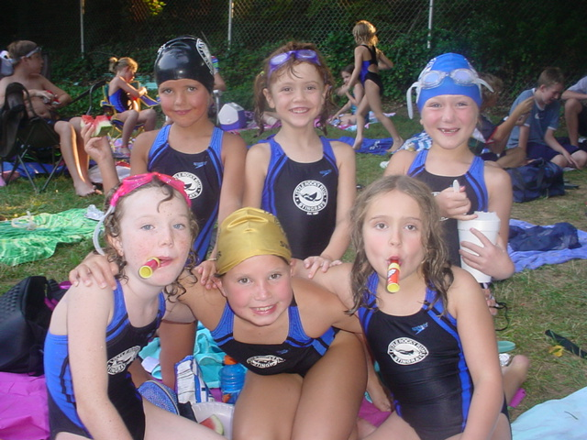
Back row L to R: Chloe Ross, Adelaide O'Connor, Shelby Rice
Front row L to R: Sarah Bishop, Madison Purvis, Caitlyn Watkinson

Interested in Winter Swim?
Although winter is far off on the calendar and it's hard to think about when the temperature is hovering around 100 degrees, we are already making arrangements for winter pool space.
After taking the 2006-2007 Winter swim season off, the Stingray's program will be back for 2007-2008. But in order for this to happen, we need to plan early and have ample participation.
As in prior years, we will have reserved lanes Sunday evenings at a local indoor pool. For 2007-2008 we will be swimming at a Fairfax County Rec Center, either Cub Run or Oakmar, instead of George Mason University's Fairfax Campus. Swimming at a Rec Center will give us more practices and less interruptions in the weekly training.
The program is open to Stingrays who will be 6-18 years old during the 2008 Summer season. A typical practice will consist of clinic-style technique instruction concentrating on various aspects of the strokes plus lap drills to maintain endurance during the off-season.
If interested, please email Chris Knoble at lrrstingrays@verizon.net. Registration information will be made available via email and at each Little Rocky Run HOA pool by July 23rd.
Featuring Our Oldest Stingray

Christy Nicholas knows what it feels like to break records. She currently holds the 9-10 and 11-12 freestyle records; although she admits Taylor Avery is right at her heels breaking a few old records. Christy has been swimming for the Stingrays since age eight and now holds the honor of being the oldest Stingray.
“First time I got recognized for going fast, I thought, oh, I like this.” Christy is talking about when she moved up from the 25m into the 9-10 age group. She broke her first record and Coach Matt Sullivan gave her a symbolic key to the pool, which she jokes, was probably a key to his garage.
Christy is now approaching her sophomore year at West Virginia Wesleyan College, where she is on both an academic and swimming scholarship. She competes in both backstroke and butterfly, however, she has been out a year and a half on butterfly due to a shoulder surgery her senior year of high school. This past Tuesday at Time Trials she swam butterfly for the first time in a year and a half. “It was okay. I’m happy with my time,” said Christy. For all those that know Christy, they will tell you that her upbeat attitude has cut her recovery time in half.
As for her academic future, Christy is pursuing an MBA with a math minor. She hopes to go into Industrial Design. We are sure you’ll accomplish all your goals Christy, as we have watched conquer the pool as an individual and team player.

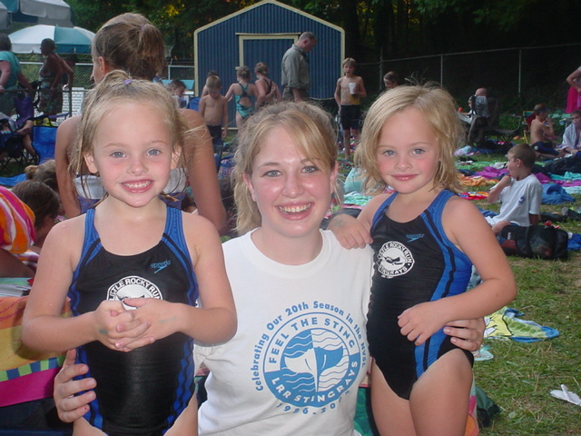
Christy Nicholas (our oldest Stingray)
and Riley and Emma Prosser (our youngest Stingrays)
End Of The Season Banquet 2007
Moe’s Southwestern Grill will once again be catering our End of Season Banquet. The adult menu features chicken fajitas or chicken or beef taco salads at a cost of $10 per person. The kids menu, for all 12 and unders, will feature cheese quesadillas or a taco bar at a cost of $6 per person. Iced Tea is included. Tickets may be purchased Monday, July 16th through Friday, July 20th at pool #2 at 9am or 11am. Look for Stephanie Purvis or Karen McCranie. Cash or check will be accepted.
Lollipop Meet
The annual Lollipop meet will be held on Sunday July 15, at 12:00 noon at pool #1. This is a time we invite young Little Rocky Run children to our pool so that they can see what the Stingray swim team has to offer.
If you know of any children, under the age of 8, who might be interested in joining our team, please encourage them to attend the lollipop meet. The children will swim across the pool and at the end of the race, get a delicious lollipop. Swimmers are allowed to use floating devices and have a parent help them across the pool, no pressure. This is meant as a fun event for young children who might want to join our team next season.

Photo Sharing Website
Stingrays now have their own photo sharing website. All of this season’s pictures from the other Fotki.com site have been edited and uploaded again.
Here is the link to website:
http://public.fotki.com/stingrays/
There's no registration required to view the pictures.
To buy prints: You may buy prints through the website, but if you have logged in with a user name and password, LOG OUT before purchasing so your payment information remains private.
Prints are only 9 cents each with $1.95 shipping for up to 50 prints. See the “Pricing” link at the bottom of the web page.
To download photos: To download to your computer. Double click on the thumbnail size to see a viewing size. Then to get a full size and resolution, click on the words below the picture "get original downloaded photo". After that loads, right click your mouse on the picture and select "save as".
To upload photos you have taken, contact MaryHelme@cox.net for the user name and password.

Coach’s Trivia
Match the Coach to their favorite food to eat before they swim:
Brolin A. Omelet
Katie B. Nachos
Elyse C. Chocolate
Andrea D. PB & J with Blue Gatorade
Moe E. Power Bar
Sarah F. Nibble on Ritz Crackers
Brett G. Oatmeal
Kathryn H. “I Don’t Eat Before Swimming.”

