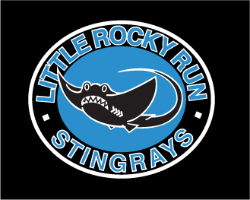
Little Rocky Run’s Issue 4 July 6, 2007

Stingrays Newsletter


Little Rocky Run Stingrays: Swimming for fun, winners for life

Stingrays Best The Riptide, 271.5 to 130.
Win Improves Team to 2-0


The Stingrays are off to a great start this year with two impressive wins. After spending last season in Division One, it is nice to be on the other side of the score.
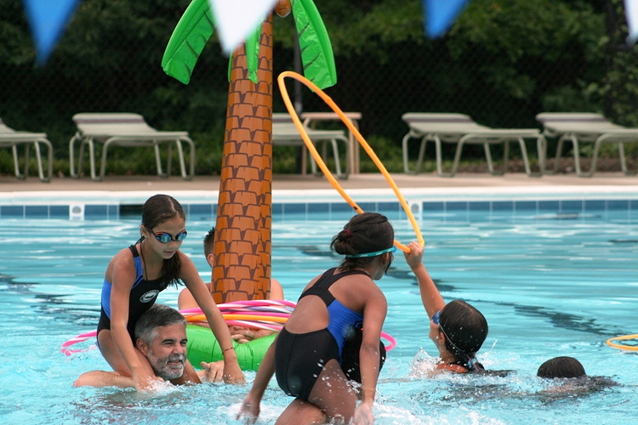
The swimmers had fun, starting off with a creative Stingray Power Rangers skit and ending with a luncheon attended by both teams. In between, the Stingrays swam many great races and racked up 50 personal bests out of 114 swims. Wow!
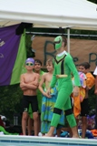
For the meet, the 9-10 girls, 11-12 girls, 13-14 boys, and 15-18 boys took first place in each of their events, outscoring the Riptide 34-7, 30-11, 31-10, and 33-8, respectively. The depth in these ages as well as the others is an asset that is paying dividends. Overall, the Stingrays won 9 of 12 relays.
Stingray first place winners were: Rachel Anderson, Taylor Avery (2), Kelsey Daily, Matthew Dietz (2), Carly Grecco, Luke Guthrie, Mo Hummel, Sean Hathaway, Sarah Hessler, Bobby Kelly (2), James Kintzing (2), Steven Kirk, Taylor Knight, Kyle Marshall, Brett Merker, Elizabeth Murphy (2), James Murphy (2), Michael O'Donnell, Shannon O'Donnell, Logan Ross (2), Abby McCranie, and Katie Yost.
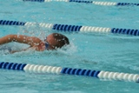
Stingray second place winners were: Jonathon Clark, Luke Guthrie, Charlotte Hathaway, Sean Hathaway, Michael Helme, Erin Hessler, Sarah Hessler, Jacob Kintzing, Taylor Knight, Katie Lesniewski, Susie Lesniewski (2), Brandon Luke, Kyle Marshall, Carson McEver, Luke Paradis, Zack Sikora, Janelle Sykes, David Welliver, Billy Yost and Katie Yost.
Stingray third place winners were: Jonathon Clark, Kelsey Daily, Jack Danisewicz, Chris Fallon, Kevin Hagan, Samuel Jackmore, Nathan Marks, Abby McCranie, Cole McCranie, Carson McEver, Brett Merker, Jessica Sussman, Grace Warhurst, Brooke Worley and Caylin Zirzow (2).
Next Up: Hunter Mill
FAMILY FUN NIGHT
Weather did not cooperate, but…

It was a lot of fun!!!
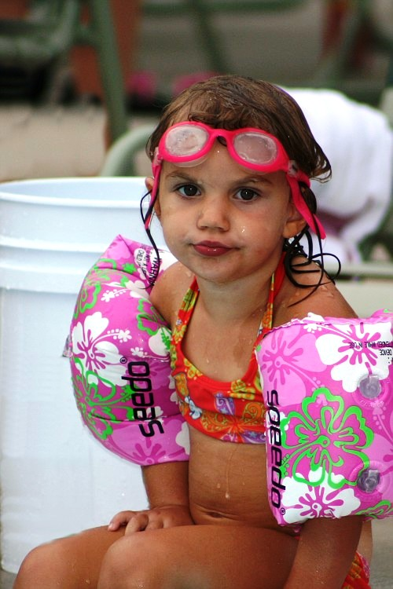
Mark Peterson mixed new games along with some old favorites for a variety of fun for all ages. The 8 & Unders had float rides, dove for deep sea treasure and collected floating dinosaurs. These treasures kept small kids in the water even when their lips turned purple.
Older kids and their parents participated in relays, float pulls, and parent/child ring toss. Everyone enjoyed Dress the "Stingray Monkey" Relay!! Several families fielded very strong teams for the family relays – you should have seen the moms and dads speeding across the pool.
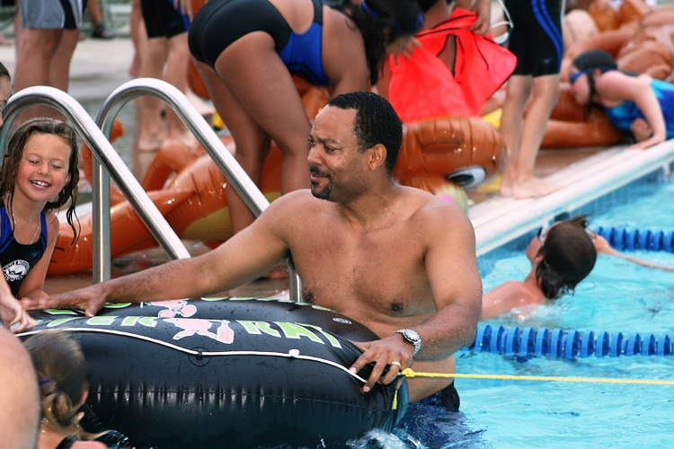
Thanks to Mark Peterson for being such a great Master of Ceremony!
Many, many thanks go to all volunteers who happily helped out. The evening would not have been a success without you.
Come back next year and we'll have fun all over again!

Important dates to remember:
Friday, July 6 Donut day
Sat., July 7 NVSL Meet #3 @ Hunter Mill
Meet starts 9:00am
Meet at Centreville HS at 7:25, caravan leaves at 7:40
Mon., July 9 Fast Meet #4 @ Commonwealth
Meet starts at 6 pm
Tues., July 10 Time Trials 6 pm
Warm up starts at 5:30 pm
Wed., July 11 Division Relays @Virginia Run
Meet starts at 6:30 pm
Friday, July 13 Pep Rally at 6:30
FAST MEET at HOME
VS. VILLA

It was great to be home again at Pool #2 for our FAST meet and the improvement in our swimmers showed on their own home turf. Overall, 150 personal bests were achieved this week, up from 109 personal bests last week. With the season in full swing, this shows that our swimmers and coaches are continuing to push barriers back and “leave it in the water.”
Lexi Benton is the most improved swimmer of the week. She improved her freestyle stroke by 36% and her backstroke by 22%. Other top personal bests in backstroke come from Emma Odom (39%), Lauren McGovern (25%), Lauren McAuliffe (23%) and Colin Tucker in the 50M by 15%. Three Stingrays improved their time in the butterfly stroke – Freddy Meny (25%), Jacob Kintzing (17%) and Katherine Bennett (16%). Emmy Rector and Benjamin O’Connor both improved their freestyle stroke by more than 20%. Other personal bests over 15% include Anna Debigh, Anna Rose Kurowski and Ryan Hess.
First place finishers included: Rachel Anderson, Logan Aunon, Matt Baron, Ally Bedell, Katherine Bennett, Kevin Bishop, Myles Brown, Anna Denbigh, Sydney Dolan, Katrina Fuentes, Kelcie Greenfelder, Coleen Knight, Grace Guthrie, Luke Guthrie, Will Hadsell, Kevin Hagan, Tyler Hagan, Melanie Helme, Allie Humes, Jacob Kintzing, James Kintzing, Rebekah Kintzing, Yevin Kim (2), Joshua Krise, Anna Rose Kurowski, Mallie Lesniewski, Susie Lesniewski, Brandon Luke, Michael Marrow, Colleen Marshall, Kyle Marshall, Collin McCranie, Rosemary McGovern, Freddy Meny, Brett Merker, Taylor Nappi (2), Logan Ross, Scott Ruelle, Katie Schwindt (2), Jessica Sussman, Billy Yost
Second place finishers included: Anna Denbigh, Nada Fawzi(2), Katrina Fuentes, Meghan Givens, Grace Guthrie, Will Hadsell, Jennifer Hagan, Melanie Helme, Noah Helms (2), Rebekah Kintzing, Monica Kirk (2), Colleen Knight, Anna Rose Kurowski, Wesley Kurowski, Brady Madden, Delaney Madden (2), , Coleen Marshall, Carson McEver, Brian McLenigan, Danny Meador, Freddy Meny, Gabie Niccitta, Andrew O’Shea, Madison Purvis (2), Shelby Rice, Kyle Richbourg, Paige Richbourg, Scott Ruelle, Katie Schwindt, Alex Simmons, Jessica Sussman, Jennifer Zenko
Third place finishers included: Tyler Aunon (2), Matt Baron, Michael Bishop, Myles Brown, Sarah Clark, Elyse Dietz, Julia Freeman, Rafael Fuentes, Pathrick Goldammer, Katie Grandinetti, Kyle Greenfelder, Charlotte Hathaway, Jack Hess, Madeleine Helms, Mitch Kiefer, Natalie King, Jacob Kintzing, Meghana Krishna, Kyle LeBlanc, Nathan Marks, Alexandra McAuliffe, Cole McCranie, Emily McLenigan, Adelaide O’Connor, Lindsey Peck, Kathryn Peterson, Mathew Rice (2), Brent Rushing, Sarah Kate Simmons, Mackenzie Ziobro

Many More Stingrays are On the Way to Gold !

Fourteen more Stingrays have achieved Gold status this week: Rachel Anderson, Jonathon Clark, Carly Grecco, Mitch Kieffer, Nathan Marks, Ben Mason, Cole McCranie, Collin McCranie, Esteban Molina, Kyle Richbourg, Logan Ross, Katie Schwindt, Billy Yost, and Brady Madden have joined the ranks of previous gold swimmers. Silver swimmers were Sarah Alberstein, Kyle Cassidy, Sarah Clark, Jack Danisewicz, Natalie King, Tim Hadsell, Tyler Hagan, Meghana Krishna, Andrew Kurowski, Kyle LaRuffa, Ashley Leightley, Danny Meador, Freddy Meny, Brett Merker, Brendan O’Shea and Madison Purvis. Reaching Bronze were Lexi Benton, Kevin Bishop, Jacob Bowman, Katie Coritz, Anna Denbigh, Kyle Greenfelder, Will Hadsell, Ryan Hess, James Holden, Sam Jackmore, Bobby Kelly, Georgia Kikis, Yevin Kim, Anna Rose Kurowski, Brandon Luke, Rosemary McGovern, Emily McLenigan, Daniel Molina, Taylor Nappi, Leah Odom, Shannon Prosser, Emmy Rechter, Ryan Ross, Jessica Sussman, Grace Warhurst, and Stephanie Zempolich.
These swimmers should all be very proud of their accomplishments! Congratulations to you all!

Coach’s Trivia
Match the coach to their favorite “pump it up” IPOD tune.
Kathryn Peterson A. Don’t Stop Me Now Queen
Sarah Worley B. Eye of the Tiger Survivor (Rocky Theme Song)
Stephanie Kelly C. Baba O’Riley The Who
Laura Freeman D. Sandstorm Darude
Mo Hummel E. Lose Yourself Eminen
Brolin Walters F. We Will Rock You Queen
Andrea Martin G. Unwritten Natasha Bendingfield
Christine Filak H. Here It Goes Again OK Go
Moe Filak I. Gone Kanye West
Bret Merker J. Right Now Van Halen
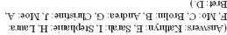
Check next week’s newsletter for more Coach’s Trivia.

Interesting Coach Fact: Coach Christine Filak’s college swim team used to watch a USA Olympic swim video to her motivating IPOD song. In the video, Jenny Thompson sets a new world record in the 100M Fly while Van Halen sang “Right Now.” Visit www.usoc.org to learn more about Jenny Thompson. Among other amazing titles, records and accomplishments, she was named one of the “Greatest 100 Female Athletes of the 20th Century“ by Sports Illustrated.

Junior Coach Tip of the Week:
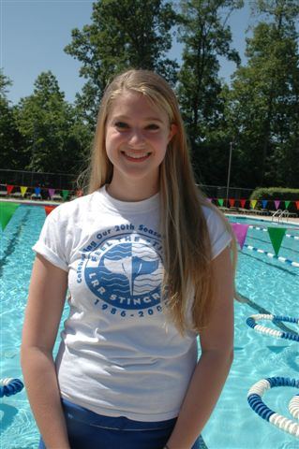
Kathryn Peterson has also been swimming for the Little Rock Run Stingrays since she was six years old. She currently is entering her junior year at Centreville High School where she swims for the Wildcats. Her tip of the week is aimed at the younger swimmers who are trying to master backstroke. “Keep your tummies up to the sky, “ said Kathryn. She should know, as she devotes her extra time to working with the 8&U swimmers in practice lanes 1&2. Thanks, Kathryn. Now head to Coach’s Trivia and guess what song motivates Kathryn before she competes.

Parent Question
of the Week
What surprised you most about the 2007 Stingray season?
Answered by Coach Filak:
What surprised me most about this season was the large number of 8 & U who were so enthusiastic about being a part of this team. It is so great to see such interest at such a young age
What goals have you set for yourself, your coaching staff and the swimmers?
Answered by Coach Filak:
The goals I have set for myself and my coaching staff are to provide the best stroke technique and advice on swimming on a day to day basis. We wish to do this using constructive criticism and positive reinforcement. It is also our ultimate goal to make the team faster as a whole and to instill enthusiasm and a love for swimming in each individual.
Please send parent’s questions to kanoconnor@aol.com. Names will be kept anonymous and will be addressed to the appropriate coach or volunteer. Questions for the board and team representatives are also encouraged.

Thank You Rebekah Kintzing!

Rebekah has joined the Stingray Staff as one of our Team Photographers. So when she's not in the water swimming, you might see her with her camera in hand, remember to smile for the camera! Thanks Rebekah!

Teammates of the Week
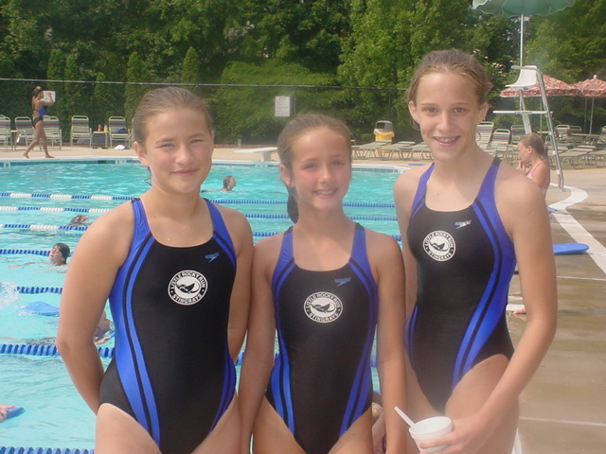
Left to right Rachel Avery, Shannon O'Donnell and Brooke Worley
At the Swim-A-Thon, we caught up with Rachel, Shannon and Brooke:
Question: What do you do to get motivated before you swim?
Rachel: "I listen to my IPOD, usually anything by Gwen Stefani." Rachel's favorite stroke is backstroke.
Shannon: "I listen to my IPOD, too. I like fast music, I listen to Panic! at the disco." Shannon's favorite stroke is breaststroke.
Brooke: "I talk to my friends and they get me pumped up for my race." Brooke's favorite stroke is also breaststroke.
Thanks for talking to us girls and for swimming to earn money for the Arthritis Foundation!
The swimmer of the week
Swimmer of the week is an acknowledgement given weekly to swimmers who show dedication, team spirit, hard work, are attentive at practice, go above and beyond each day, or step up to a challenge when called upon by the coaches. All swimmers are eligible for this award.
We would like acknowledge the following swimmers who have received the title of Swimmer of the Week thus far throughout the season. Keep up the great work!
15-18 13-14
Brett Merker Tyler Aunon
Matt Dietz Zach Sussman
Mo Hummel Emily McLenigan
Sarah Worley Erin Hessler
11-12 9-10
Logan Aunon Carson McEver
Adam Summers Michael Bishop
Shannon O'Donnell Charlotte Hathaway
Sarah Alberstein Jackie O'Shea
8-U
Miles Brown Brandon Luke
Nathan Goldammer Will Hadsell
Chloe Ross Sidney Kiefaber
Madison Purvis Anna Denbigh
Reminder to the recipients of Swimmer of the Week, if you have not picked up your shirt please see a coach at practice so we can get one to you
Motivational Quotes from Olympic Champions
Reprinted from www.swimpsychology.com:
"Mainly, I like to have fun. Swimming is all about having fun, and I am firm believer that you should keep swimming as long as you are having fun, but I can say that it becomes much more fun as you get older and learn more about the sport, life, and especially more about yourself".
Scott Goldblatt , won the Gold, Athens 2004.
"I wouldn't say anything is impossible. I think that everything is possible as long as you put your mind to it and put the work and time into it".
Michael Phelps, seven-time Gold Medalist at 2007 World Championships.
"I told myself there was no way I was going to let this training go to waste. It was my time, and I was ready to go."
Katie Hoff, won three Gold Medals at the World Championships in July 2005.

"There is water in every lane, so it is OK."
Ian Thorpe (on being in Lane 5 for a final), Olympic and World Champion swimmer from Australia.

"Susie had no talent whatsoever. She's a little person who couldn't even make a final at a state meet - coming and showing the world that on sheer guts and determination you can do anything you want!"
Susie Maroney's coach Dick Caine after her 200 kilometers marathon swim from Mexico to Cuba.

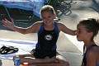

Kings Dominion /Splash Down



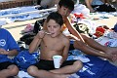
Once again this season the Stingrays will be enjoying day trips to
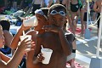
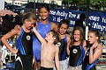

Kings Dominion and SplashDown Waterpark. The original dates for these activities
will be switched. The Stingrays will be enjoying SplashDown Waterpark on Thursday,
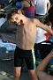



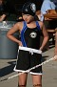

July 19th. The week after that we will be heading down to Kings Dominion on
Wednesday, July 25th. More information on both of these events will follow but
be watching for how you can get tickets! Mark your calendars now!



You won't want to miss out on either of these events!



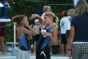

Swimathon was a
HUGE Hit!
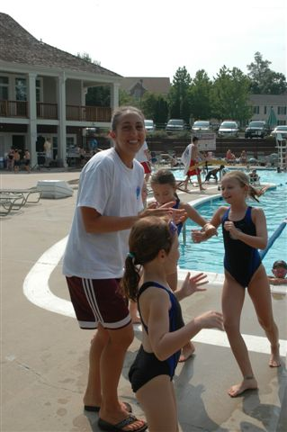
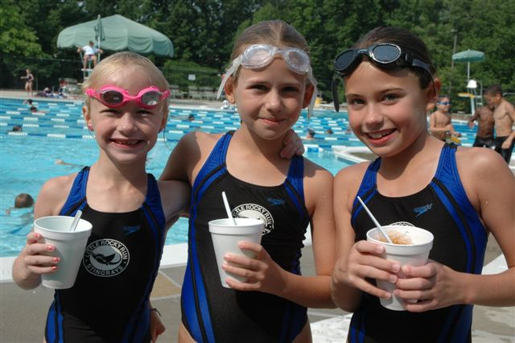
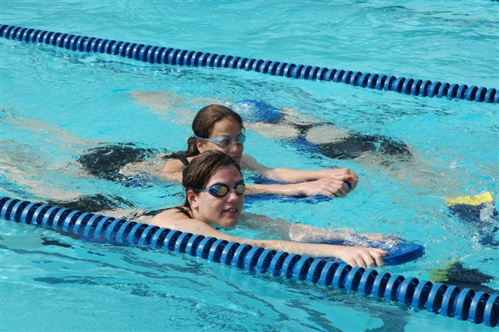
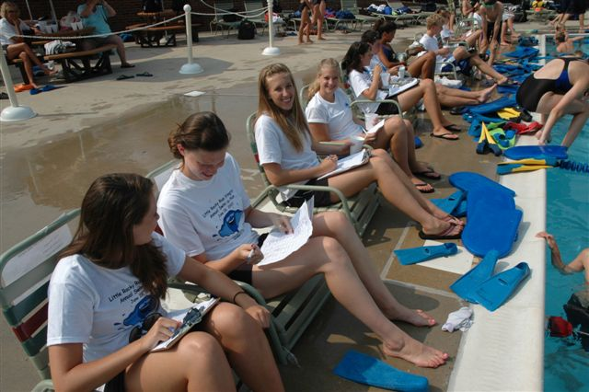
The pledges are still being collected but from what we can tell at this point, it looks like we have earned more money this year than we did last year! Great Job everyone! As you know, we were raising money for The Arthritis Foundation of the Washington Metro Area. These funds will go directly to help children with Arthritis in our immediate area, thanks for reaching out and helping kids who face the challenge of dealing with this chronic disease. Special thanks to Susan Brown and Heidi Peck who were the co-leaders of this event, they did a great job! All the parents who helped were so spirited it made the event even more special. Also, special thanks to all the coaching staff who tallied the laps, danced and showed the stingrays how much fun it can be to help others.
Stingrays vs Villa FUN in a SUN

