Information for Team Reps
NVSL ALL-STAR RELAY CARNIVAL – JULY 18, 2012 4:00 PM
Meet Mangers: Jim Shlesinger (NVSL), Gina Barry (LP) 571-243-8058
PRE-MEET ACTIVITES
TEAM SCRATCHES: Team Reps should provide any TEAM scratches to your Division Coordinator by 1:30 PM, Saturday, July 14, so they can be reflected in the Meet program and alternate teams can be notified.
SWIMMER SUBSTITUTIONS: One swimmer substitution may be made at any time (see NVSL rule 5.c.). Substitutions made by the Team Scratch deadline (see above) will also have the substitute’s name printed in the meet program.
MEET OFFICIALS: Following the Seeding Meeting, Division Coordinators will identify each team’s requirements for Meet Officials. Team Reps are to provide names of persons working as officials to your Division Coordinator by 12:00 PM, Sunday, July 15th so they can be published in the Meet Program and placed on the parking lot access list. Prior to the meet Team Reps must notify their Officials working the meet to sign-in and receive Name Tags for access to deck areas. Deck Officials are to arrive no later than 3 PM. Failure to provide a name prior the publication cutoff times does not relieve the Division/Team of their obligation.
ALL-STAR SALES/MEET PROGRAMS: At the Pool Familiarization and on Meet Day, All-Star T-shirts, Swim Caps, and meet programs will be available for purchase. Team orders placed per the instructions on the form are guaranteed to receive T-shirts in the sizes and quantity ordered. *NEW* One voucher will be included with team orders for the total number of programs purchased by your team rather than individual coupons. Please assign a representative from your team to bring the voucher on Meet Day to pick up all of the programs for your team and distribute them in your team area. The following items are available:
Item | Individual Price | Team Price
T-shirts | $20.00 | $19.00 | Child large and Adult S thru XL
T-shirts | $22.00 | $21.00 | Adult XXL
Swim Cap | $5.00 | $4.00
Meet Program | $5.00 | $4.00 | **NEW** Team Reps will be provided one voucher for the total number of programs ordered for their team.
** A Team Order Form can be found on the NVSL website.
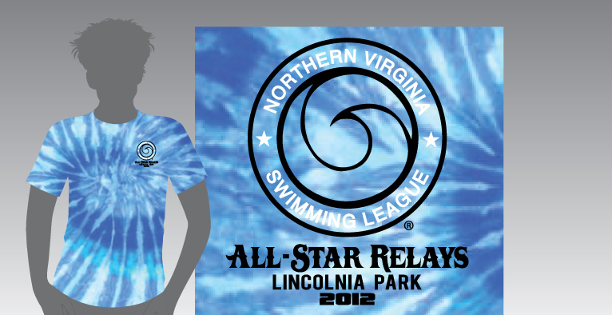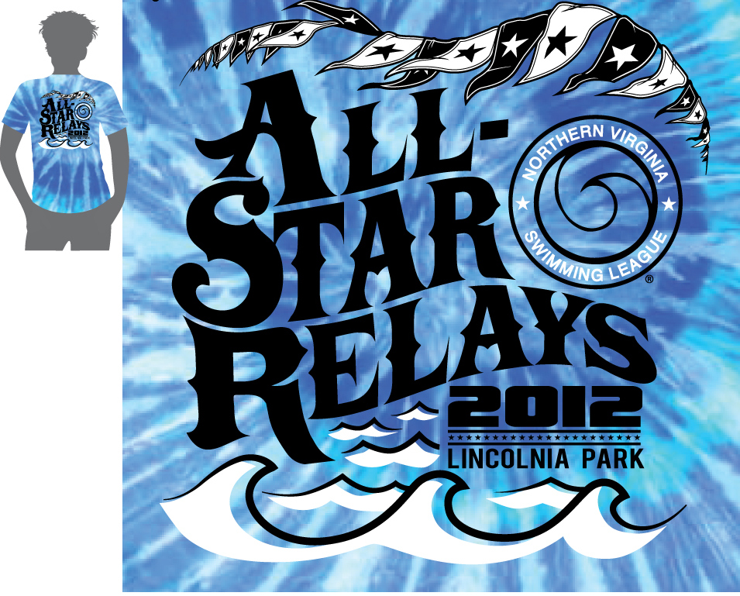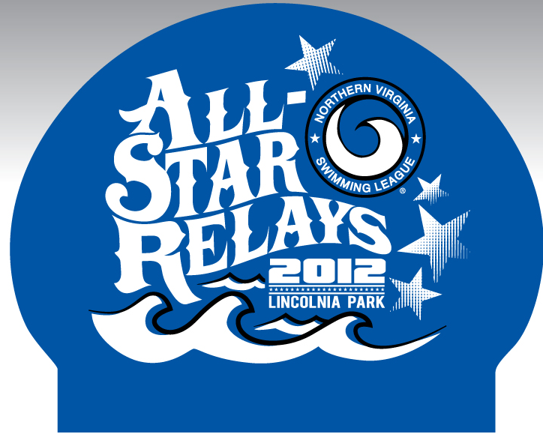
Shirt front Shirt back Cap
POOL FAMILIARIZATION: Pool Familiarization will be held on Sunday, July 15, 8 - 11AM.

Information for Team Reps
NVSL ALL-STAR RELAY CARNIVAL – JULY 18, 2012 4:00 PM

DAY OF THE MEET
WHAT TO BRING: A list of All Star Relay Carnival swimmer and alternates for use in the Awards Area. Upon arrival, Team Reps and the Head Coach should report to the Team Rep/Coach/VIP Check-in. Team Reps must turn in their list of swimmers and alternates at check-in. All Star Patches will then be provided with your awards.
NAME TAGS AND PROGRAMS: Simply sign-in to receive your team’s meet program, the Coaches’ meet sheet, and the Team Rep and Coaches name Tags for access to reserved viewing areas. Seating areas only allow for one Team Rep and one Coach Badge per team.
SWIMMER SUBSTITUTIONS: One swimmer substitution may be made at any time (See NVSL rule 5c). In order to obtain ribbons and results, with the substitution swimmer’s name, you must notify the Scorer of the swimmer substitution prior to 3:00 PM meet day or wait until the conclusion of the meet.
ALTERNATE TEAMS: Alternate Teams should report to the Clerk of Course when their event is called. Alternate Teams will be escorted to the deck and will be seeded in to the meet should a seeded team not be allow to compete. Alternate Teams receive All-Star Patches.
AWARDS AND PATCHES: Team Reps should pick up their team’s medals, ribbons, and patches at the Awards Area after your team’s last event (Awards are usually ready 3 to 4 events after they occur). Trophies are awarded at the end of the meet to teams finishing in the first six places.

